US Forest Service Technical Assistance Mission
Water Resources in Tabora and Rukwa Regions, Tanzania
May 17 – June 5, 2009

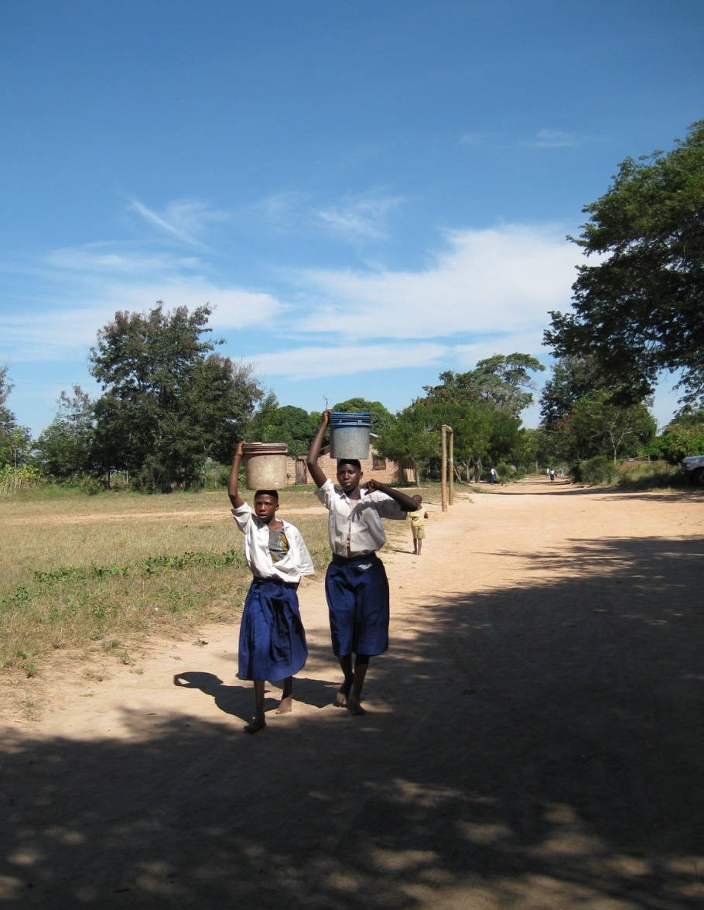

June 2009

Prepared by
Robert Sassor
Water Resources Manager
USDA Forest Service
International Programs
Kigoma, Tanzania
Email: rob_sassor@yahoo.com

Beverly Young
Environmental Engineer
USDA Forest Service
Northern Region
PO Box 7669
Missoula, MT 59807
Email: byoung01@fs.fed.us

Joe Gurrieri
Geology & Ground-Water Programs
USDA Forest Service
Intermountain Region
324 25th Street
Ogden, UT 84401
Email: jgurrieri@fs.fed.us

Contents

Acknowledgements iii
Acronyms and Abbreviations iv
1. Executive Summary 1
2. Introduction 2
2.1 Geographic Context 2
2.2 Climate 3
3. Background and Context: Water Quality 5
3.1 Source Water Protection 6
3.2 Water Quality Standards and Monitoring 7
4. Background and Context: Hydrogeology 9
4.1 Hydrogeologic Setting 9
4.1.1 Tabora Region: Urambo, Uyui, and Sikonge Districts 9
4.1.2 Rukwa Region: Mpanda District 13
5. Field Visits and Observations 15
5.1 Field Visits 15
5.2 Observations 16
6. Recommendations 18
6.1. Borehole Drilling 18
6.2 Pump Installation 18
6.3 Source Protection and Village Water Point Management 19
6.4 Periodic Sanitary Inspections and Water Quality Testing 19
6.5 Technical Capacity Development 19
6.6 Tabora Region, Sikonge District 20
6.7 Rukwa Region, Mpanda District 20
Glossary 21
Bibliography 22

Appendix 1: Mission Terms of Reference 25
Appendix 2: Mission Itinerary 27
Appendix 3: Individuals Consulted 34
Appendix 4: Potable Water Standards 36
Appendix 5: Geophysical Survey Techniques 38
Appendix 6: Notes from Locations Visited 39
Appendix 7: Handpump Documentation 50
1. Afridev Deepwell Handpump 50
2. India Mark II Handpump 50
3. India Mark III Deepwell Handpump 50
4. NIRA Handpump 51
5. Vergnet Hydropump HPV 60 / HPV 100 52
Appendix 8: Borehole Drilling – Project and Contract Design 53

Credits
Cover photo © 2009 Beverly Young

Acknowledgements

This mission was seamlessly organized and carried out due to the unflagging efforts of many people.

First, our gratitude to colleagues at Africare who organized mission logistics and helped ensure the mission made a maximum impact:

- Shidumu Mawe, whose spirited lessons to villages about sanitation and health were memorable for all of us;
- Calvin Meta, who masterfully handled issues as they arose and served as our cultural and linguistic liaison; and
- Africare’s Field Officers who organized local logistics and will ensure project continuity: Edward Masawe in Urambo, Linus Salema in Sikonge and Eliya Mgalihya in Mpanda.

Furthermore, we are grateful to District staff who welcomed us to their villages, facilitated introductions and will ensure that local USAID-sponsored water resource projects will be properly maintained:

- Lucky Mgeni and Faustino Misango, the Acting District Water Engineers for Urambo and Uyui Districts respectively;
- Sikonge District staff, including Paschal Ngunda, the District Water Engineerk, Jafari Wibonella, Senior Technician for the Water Department, and Severino Kagyabukamo, Pump Technician; and
- Enock Msengi, District Water Engineer for Mpanda.

Finally, our thanks to Rafael and Uledi, Africare’s drivers, whose good cheer and careful driving made our long trips enjoyable and safe.

Acronyms and Abbreviations

CBO Community Based Organization
DTW depth to water
DWE District Water Engineer
GPS Global Positioning System
LUP Village land-use management plan
MIMAMPI Misitu na Mazingira Mpimbwe (a CBO operating in Mpanda District)
MDG United Nations Millennium Development Goal
NAWAPO Tanzania’s National Water Policy of 2002
NGO Non-governmental organization
NRWSSP National Rural Water Supply and Sanitation Program
SWL static water level
UCLCP Ugalla Community Landscape Conservation Project of Africare
UN United Nations
USAID United States Agency for International Development
USFS United States Department of Agriculture Forest Service
VLF very low frequency
VLOM Village Level Operated Maintenance
WASH Water, Sanitation and Hygiene
WHO World Health Organization
WMA Wildlife Management Area

Executive Summary
The US Forest Service (USFS), in conjunction with the US Agency for International Development (USAID), is working with Africare to provide twelve boreholes in the Tabora and Rukwa regions in 2009. The purpose of this USFS mission was to visit the villages selected for an improved water source in order to: inform water scheme design and placement based on best practices and international water quality standards; increase the capacity of officials and villagers to implement water and sanitation best practices and manage sustainable water points; promote health and sanitation related to water source protection; encourage compliance with Tanzanian law regarding community investments in water schemes and equal gender representation among water user groups; and promote project sustainability.

The three-week field visit enabled USFS consultants to review existing geologic, climatic, hydrologic and borehole data, and to conduct hydrogeological analyses and an inventory and assessment of existing water points. This report details field observations and recommendations both general to overall water point development and specific to sites visited.

Recommendations for borehole development call first for geophysical surveys to site locations for drilling two or three exploratory, small diameter boreholes which will increase the probability of finding an adequate supply of groundwater. Further success will be strengthened by having a qualified independent supervising hydrogeologist at the drill site. Drilling contracts should use the language and specifications recommended by the Lake Tanganyika Water Basin staff. Drilling logs, even those from nonproductive boreholes, represent critical information to be shared with Africare, the District Water Engineer and the appropriate Water Basin Office.

Groundwater samples for physical and chemical parameters need to be collected at the time of borehole completion, with bacteriological samples collected and analyzed after the handpumps are installed. The suitable handpumps for village level operations and maintenance are Nira-85 for shallow wells and Afridev for deepwells. Long-term viability of the developed sources will be ensured by an adequate source protection area. A fenced area of 30 meter radius around the borehole or shallow well, with restricted activities within, was recommended to and supported by the village water committees. Many abandoned shallow wells were observed and should be properly filled to remove contaminant pathways to the aquifer.

Additional water sector support could be given to these activities to further expand access to improved water sources and strengthen institutional capacity:
- protect and improve existing shallow wells, especially in the Tabora region, which has the second least access to improved water in Tanzania (WaterAid 2006);
- develop institutional capacity to perform microbiological testing;
- develop a database to store borehole information;
- begin a groundwater mapping program; and
- sponsor a technical training workshop on groundwater development.

Introduction
Safe water is a basic human necessity which is in scarce supply in many parts of Tanzania. The Tanzanian Government reports that only half the nation’s rural population has access to a water source (United Republic of Tanzania, 2002). And despite excellent efforts by a variety of institutions, over 30% of rural water schemes are nonoperational due to poor maintenance (Ibid).

The Tabora region is one of Tanzania’s regions with the least access to improved water sources, with an estimated 13% of rural households able to access such sources (WaterAid Tanzania 2004). The percentage of households using improved water sources is higher in the Rukwa Region (48%) (Ibid), although within the Mpanda District many villages still have an insufficient water supply.

Through generous funding from USAID, the Ugalla Community Landscape Conservation Project (UCLCP) of Africare will be installing twelve boreholes in the Tabora and Rukwa regions in June through September 2009. The purpose of this US Forest Service (USFS) mission was to visit the villages selected for an improved water source in order to: inform water scheme design and placement based on best practices and international water quality standards; increase the capacity of ward and village officials and villagers to implement water and sanitation best practices and manage sustainable water points; promote health and sanitation related to water source protection; encourage the compliance with Tanzanian law regarding community investments in water schemes and equal gender representation among water user groups; and promote project sustainability. Appendix 1 contains the mission’s terms of reference.

These tasks were accomplished May 17 through June 3 in close collaboration with Africare, District Water Engineers and representatives of the community-based organization (CBO) operating in the Mpanda district of Rukwa region named Misitu na Mazingira Mpimbwe (MIMAMPI). See Appendix 2 for the mission itinerary and Appendix 3 for key contacts made during the mission.

2.1 Geographic Context
A total of 2,100 km were traveled to evaluate water resource opportunities in the following twelve villages of the Tabora and Rukwa regions, the locations of which are shown in Figure 1:
Rukwa Region
- Mpanda District
  - Usense sub-village of Uruwira
  - Kibaoni
  - Ilalangulu
  - Kikulwe sub-village of Ikuba
  - Makuyugu sub-village of Mamba
  - Majimoto
Tabora Region
- Urambo District
  - Nsogolo
  - Izengabatogilwe
- Uyui District
  - Utura
- Sikonge District
  - Utimule
  - Msuva villages
  - Usega sub-village of Sikonge
Figure 1:Village Locations for Improved Water Supplies. 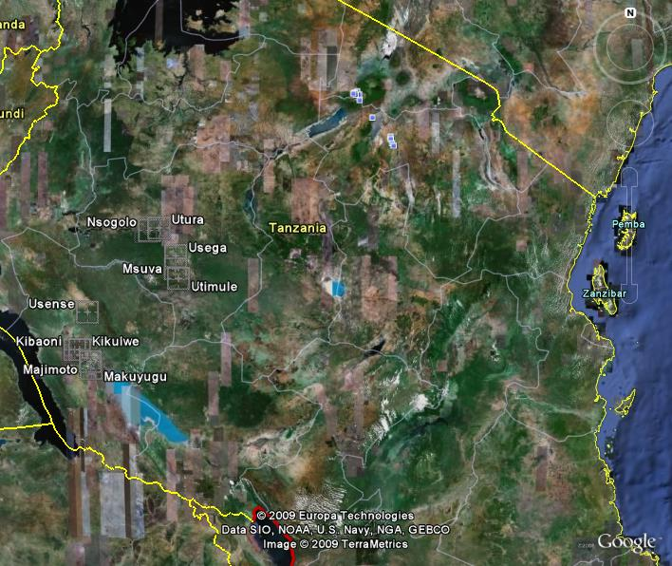
Ilalanguru
Izenga.

2.2 Climate
Water resources are inextricably linked with climate, so the prospect of global climate change has serious implications for water resources and regional development in Tanzania. Efforts to provide adequate water resources for the region will confront several challenges, including population pressure, problems associated with land use such as sanitation, and possible ecological consequences of local temperature and rainfall changes.

The Tabora and Rukwa regions have a semi-humid tropical climate and receive an annual rainfall of 800 to 1100 mm (Fig. 2). Mean annual precipitation at the Tabora airport is 1010 mm, with the majority (~90%) falling during the six-month rainy season between November and April. The rainfall is bimodal with the wet season between November and May and a dry season in the months of January and February. A long dry period occurs between June and October. The amount of rainfall that infiltrates to groundwater varies from 50 to 300 mm/year (Hydrogeologic Map of Africa).

Forested areas provide a steady supply of surface and groundwater to surrounding areas. Although the consequences of deforestation on rainfall are difficult to assess in quantitative terms, deforestation may decrease the amount of water that infiltrates to recharge aquifers and maintain spring flows. The remaining forests in the region are critical to providing a slow, steady release of water to streams and springs and maintaining a perennial flow, as well as maintaining recharge to aquifer systems.
Figure 2: Precipitation in southern Africa. (The red line represents the global average precipitation of 860 mm.)
Source: Woodrow Wilson International Center for Scholars, 2006.

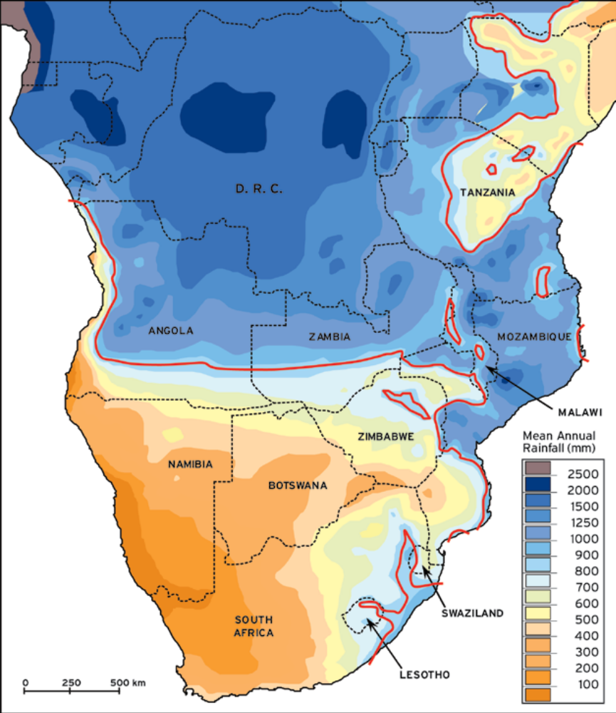

Background and Context: Water Quality
The UN General Assembly declared the period from 2005 to 2015 as the International Decade for Action with a goal to halve, by 2015, the percent of the population without sustainable access to safe drinking water and basic sanitation. The United Nations Millennium Development Goals (MDG) support the right of communities to have access to an adequate supply of safe water. “Safe water” meets the following criteria:
- it does not represent a significant health risk;
- is of sufficient quantity to meet all domestic needs;
- is available continuously to all of the population; and
- is affordable.

Adequate rural water supplies - in addition to addressing the goals of sufficient quantity and quality - also extend benefits to education (e.g. more time for schooling), income generation and improved livelihoods.

The World Health Organization (WHO) has defined a basic level of service as 20 liters per capita per day within a 30 minute round trip or within 1 kilometer. The Tanzania National Water Policy (July 2002) states that the level of service for domestic water supply in rural areas shall be “a protected, year-round supply of 25 liters of potable water per capita per day through a water point located within 400 meters from the furthest homestead and serving 250 persons per outlet.”

The Tanzanian policy focuses on integrating water supply, sanitation services and hygiene education with a platform of gender equality, empowerment of women and community planning, supervision and management.

Community participation and management is known to be important to ensure the sustainability of community water projects. Consideration of consumers’ willingness to pay for water also ensures more equitable and sustained use of the improved water supplies.

The Tanzanian National Strategy for Growth and Reduction of Poverty (June 2005) reports that 53% of the rural population has access to improved drinking water sources. The national development strategy, “Mkukuta,” targets to increase proportions of the rural population with access to clean and safe water from 53% in 2003 to 65% by 2010, 79% by 2015 and to 90% by 2025 for the rural population. These targets are supported by the National Rural Water Supply and Sanitation Program (NRWSSP), formulated through a participatory approach involving communities, NGOs, private sector and the Tanzanian Government.

Regional and district statistics for improved water sources were difficult to isolate, though several dated sources were found. In the two regions covered by this USAID project, the rural access to improved water was reported as 13.2% in Tabora and 47.9% in Rukwa(WaterAid Tanzania2004). WaterAid conducted a water point mapping project in the Tabora region and listed district and ward coverage for functional water points. A functional water point is defined as one that yields water for at least six months of the year and is being used by people as a water source on a day-to-day basis. During that same time period, the organization Research on Poverty Alleviation, Tanzania, electronically published a report listing the districts with the greatest and least access to improved water. The Tabora districts targeted for this mission were among the districts with the least access in both reports, with Sikonge district, notably, at the bottom of the list.

Table 1: Water point access in three Districts of Tabora Region.
District/Ward | Per cent of Population served by a functional water point, WaterAid, 2004 | Per cent of households  with access to improved water  (piped or protected source)  Poverty & Human Development Report, 2005
Urambo | 6 | 14
Uyumbu Ward | 2
Uyui | 7 | 11
Mabama Ward | 9
Sikonge | 3 | 7
Sikonge Ward | 7
Ipole Ward | 2

The provision of improved water points alone is not sufficient to supply sustainable access to safe water. It has been estimated that between 20% and 70% of installed handpumps in Sub-Saharan Africa are not functioning (UNICEF 2007). The high rate of failure can be attributed to technological reasons – poor construction, high cost of spare parts, inappropriate technology – but also social and institutional factors. This project is attempting to address all of these through village involvement and ownership, financial capacity building and an appropriate technical approach including proper borehole development and the specification for handpumps that can be maintained at a village level.

3.1 Source Water Protection
Resource protection and source water protection provide the first barriers in protection of drinking-water quality. Source water protection takes into account the hazards contributing pollution such as latrines, animal wastes, agricultural chemicals and industrial sources. Other factors affecting source water can be direct pathways into the aquifer such as abandoned wells, leaking pipes and catchment areas. Specifically for boreholes with handpumps, the risks to source water are:
- entering of contaminated surface water directly into borehole;
- entering of contaminants due to poor construction or damage to the borehole casing; and
- leaching of microbiological and other contaminants into the aquifer.

Control measures for groundwater sources should include protecting the aquifer and the local area around the borehole from contamination and ensuring the physical integrity of the well (surface sealed, casing intact, etc.). In the United States, federal regulations require the delineation and assessment of potential contaminants in the source water protection area and strongly encourage the development of a source water protection plan. The critical area is identified as the control zone or exclusion zone. It is an area of at least 30 meter radius around the well. The Tanzanian Standard for Drinking Water 5.4.4.1 has a requirement of fencing a 50 meter radius around the water intake to protect it from animals, pit latrines and septic tanks.
Effective resource and source protection includes the following elements:
- developing and implementing a catchment management plan, which includes control measures to protect surface water and groundwater sources;
- ensuring that planning regulations include the protection of water resources (land-use planning and watershed management) from potentially polluting activities and that those regulations are enforced; and
- promoting awareness in the community about the impact of human activity on water quality.

3.2 Water Quality Standards and Monitoring
To insure a safe supply of drinking water, the source must be free from microbes and parasites as well as chemical, physical and radiological hazards that constitute a threat to health. Infectious waterborne diseases such as diarrhea, typhoid and cholera are leading causes of death and illness in the developing world. Drinking water must also be acceptable in terms of taste, appearance and odor so that individuals will choose this water rather than polluted alternatives that may taste better or look more attractive. Since water can rarely be treated, protection of the source and the contributing infiltration area is of utmost importance.

The WHO establishes international standards for drinking water, which are health-based as well as aesthetic. The control of microbial quality in drinking water sources remains the highest priority for the WHO with thermotolerant coliform bacteria (Escherichia coli) being the indicator of choice for microbiological quality. Only a few chemicals have been shown to cause widespread health effects in humans as a consequence of exposure through drinking water when they are present in excessive quantities. These include fluoride, arsenic and nitrate.

Exposure to high levels of fluoride, which occurs naturally and is quite high in certain areas of Tanzania, can lead to mottling of teeth and, in severe cases, crippling skeletal fluorosis. Mjengera and Mkongo reported fluoride levels for the Tabora region, averaging 1.20 mg/l with a range of 0.00 - 7.60 mg/l in 44 samples collected in 1974. Elevated fluoride is more common in areas underlain by volcanic rocks which don’t occur in the Tabora or Rukwa regions.

Similarly, arsenic occurs naturally and excess exposure to it in drinking-water may result in a significant risk of cancer and skin lesions. Elevated levels of arsenic have been reported by Kassenga and Mato (2008) in the mining areas of Lake Victoria Basin but no elevated arsenic data is known from the Tabora or Rukwa regions.

Increased levels of nitrate in groundwater and surface water are typically a result of leaching or runoff from agricultural fertilizers or contamination from human or animal wastes. Elevated nitrate in groundwater has been documented in the Dodoma area but not, as yet, in the Tabora or Rukwa regions. Documentation of nitrate contamination in wells is hampered by a lack of data. High levels of nitrate can lead to methaemoglobinaemia in bottle-fed infants.

The Tanzania Standard TZS 789:2008 prescribes the water quality requirements for drinking water, including community standpipes and wells (see Appendix 4 for Tanzania Standards). The microbiological standard for Tanzania and the WHO is that there be no coliform (E. coli) in water supplies. See Appendix 4 for specifications related to nitrates, fluoride, arsenic and other contaminants.

Groundwater quality data in the area is sparse but a few reports were acquired as part of a groundwater investigation in 1991 (Ministry of Water 1991). Turbidity ranged from 2 to 85 NTU, conductivity ranged from 231 to 880 mS/cm, pH ranged from 7.2 to 8.0, alkalinity ranged from 110 to 400 mg/L, and hardness ranged from 130 to 460 mg/L. There are some wells particularly in the Mpanda District that are not used because of elevated salinity. The salinity is probably sourced from the playa deposits in the Rukwa Graben.

Background and Context: Hydrogeology
A logical and low-cost approach to determining the site for a borehole should have the following sequential levels of investigation:

Level 1: Review of Existing data

Geological data
Hydrological and climatic data
Existing borehole data

Level 2: Hydrogeological reconnaissance

Geomorphological analysis
Water points inventory and assessment
Hydro-climatic assessment

Level 3: Geophysical Survey

Electrical resistivity
Seismic refraction
Electromagnetic profiling (EM)
Very low frequency (VLF) profiling

Level 4: Exploratory Drilling

Machine drilling
Geological logging
Geophysical logging
Test pumping
Water sampling

During this mission, the US Forest Service completed Levels 1 and 2 and made recommendations on how levels 3 and 4 should proceed.

4.1 Hydrogeologic Setting

4.1.1 Tabora Region: Urambo, Uyui, and Sikonge Districts
The rivers in the Tabora region drain west into Lake Tanganyika. The region consists of gently rolling plains of low relief with extensive wetlands (mbugas). These wetlands occur in low-lying areas and are formed by perched water tables often overlying clay substrates. In the basement rock aquifers the flow of groundwater is controlled by topography. Flows are from higher elevations to lower elevations. In flat areas groundwater flow is minimal.

The Tabora region (of which the Urambo, Uyui, and Sikonge districts were visited on this mission) is underlain by weathered, ancient (Precambrian) crystalline, basement rocks (Fig 3) (Geology of Tanzania, 2005). These rocks are generally of low permeability and as a consequence infiltration and aquifer storage is limited. No major faulting has been recognized. The frequency of rock outcrops and linements are scarce due to erosion which has obliterated much of the structural evidence. Although the aquifers have a regional occurrence, they respond variably to pumping, due either to discontinuities or barrier boundaries within the fracture system being tapped or to the constraints of the low-permeability regolith. These features are commonly reflected in a significant borehole failure rate and a wide range of yields, despite the apparent regional uniformity of the basic controls of climate, morphology and geology (Wright & Burgess 1992). The transmissivity of this aquifer is low, on the order of 1 to 100 m²/day. Yields range up to 8,000 liters/hr in Urambo district but are generally less than 1,000 liters/hr in Sikonge district.
Source: MacDonald, et al. 2005
Figure 3: Simplified hydrogeological map of sub-Saharan Africa showing the number of rural people living on each hydrogeologic setting. Tanzania is dominated by basement rock aquifers.

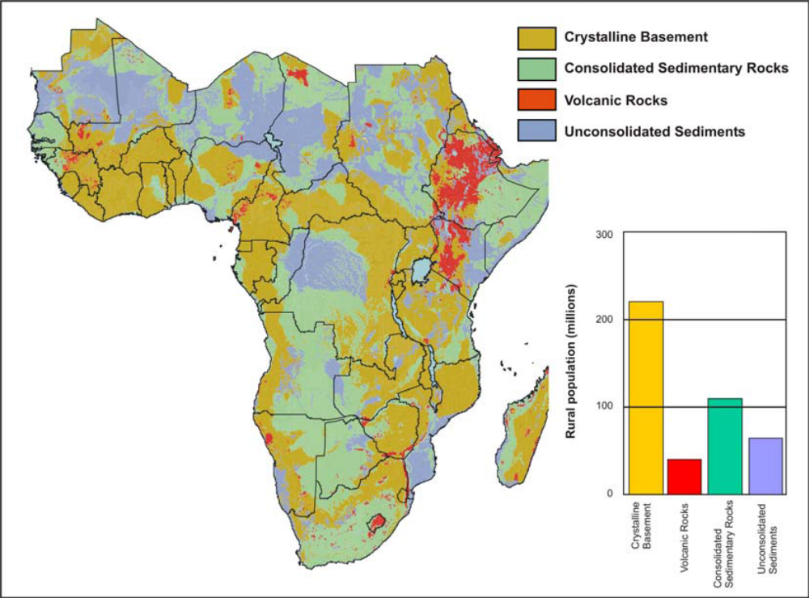

Shallow groundwater is encountered in sands and gravels of the weathered surface materials and in sandy layers that underlie ferricrete deposits. Many of the wetlands and hand dug wells in this area are supported by shallow perched groundwater systems. Deeper aquifers are encountered within the weathered or fractured bedrock. A hydrogeologic conceptual model for basement rock aquifers in areas with some relief are shown in Figure 4.

Figure 4: Diagrammatic basement complex hydrogeology in an area with some relief. The weathered regolith zone is thinner on the ridges and thicker in the valleys. Reasonable quantities of water can be obtained from thick saprolite in valleys, the basal breccia, and from major fault and fracture zones in bedrock.

A
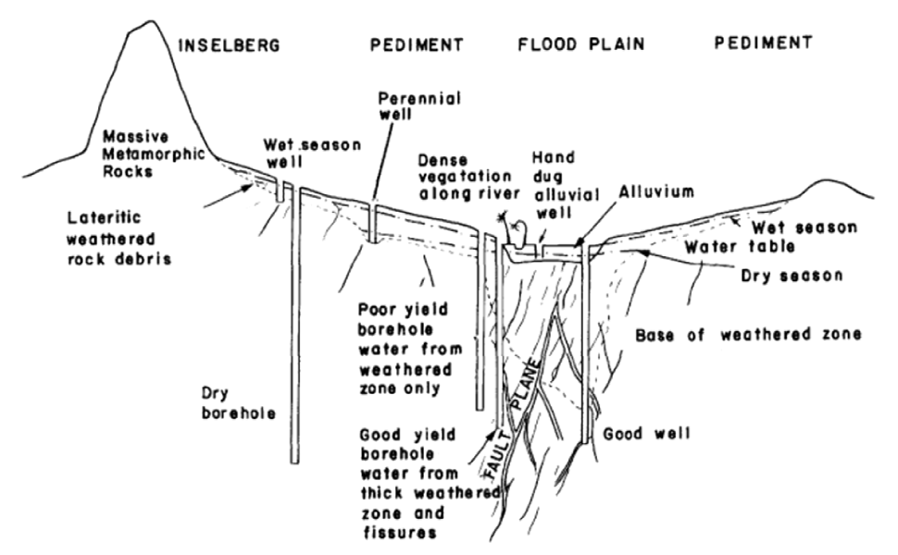
B
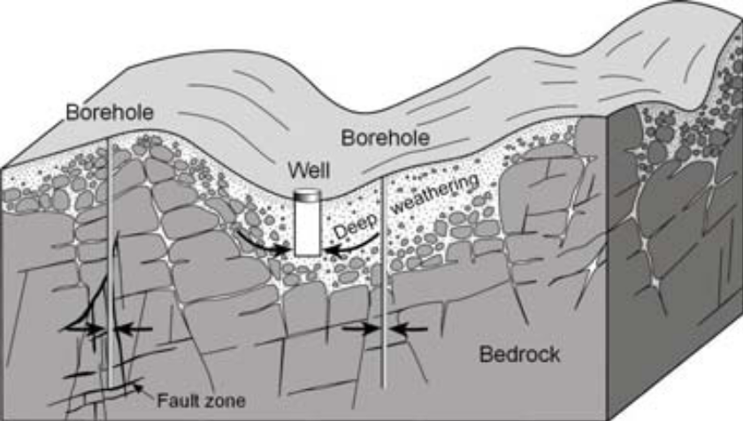
Sources: A: Acworth, 1987; B: Clark, 1985; and International Association of Hydrogeologists, Briefing Note, Groundwater and Rural Water Supply in Africa.

Wright & Burgess (1992) list a number of constraints to development of basement aquifers which include: 1) the frequent high failure rate of boreholes, commonly in the range 10-40%; 2) shallow groundwater and permeable fractures in the bedrock aquifer component which makes for susceptibility to surface pollutants and drought; 3) the low storativity of basement aquifers which may cause wells to go dry during sustained drought periods; and 4) aquifer recharge is sensitive to certain land-use changes.

Basement rock aquifers occur within the weathered residual overburden (the regolith or saprolite) and the fractured bedrock. To contain significant aquifers, the weathered profile must attain a significant areal extent and thickness and have sufficient hydraulic conductivity and storage to yield groundwater to wells or boreholes. From Fig. 5 it may be seen that these conditions are only met in the lower weathering zones 'c' and 'd'. The clay rich zone 'b', while containing significant storage when saturated, normally acts as an aquiclude and groundwater in zones 'c' and 'd' may be confined by this zone 'b' material. However zone ‘b’ can also locally be

Figure 5: Vertical profile through crystalline basement rocks showing variation of weathering, permeability and porosity. Permeability varies with lithology. Zones ‘a’ and ‘b’ are derived by in situ weathering of the bedrock and permeability commonly increases at lower levels due to a lesser development of secondary clay minerals. Permeability in zones ‘c’ and ‘d’ are generally increased as result of weathering (as compared with fresh bedrock) unless infilled by clay minerals. Permeability of fresh fractured bedrock is dependent on location and degree of fracturing.

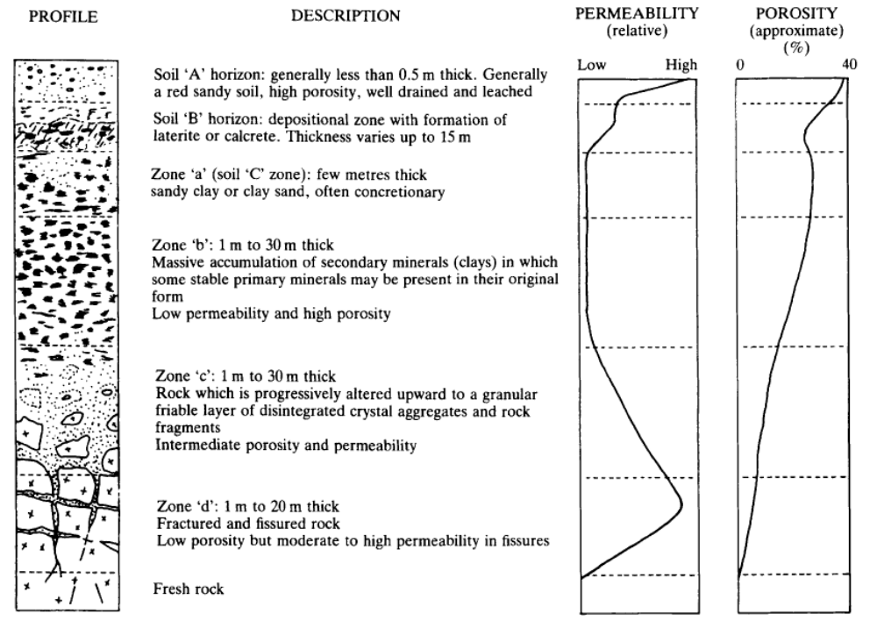
Source: Acworth, 1987.

semi-confining or not confining at all leading to contamination migrating from the surface due to poor land-use practices. The most productive borehole sites are usually those which pass through 10 m to 15 m of zone 'c' weathering and then intercept fractures in zone 'd.' The fractures produce a high permeability while the disaggregated zone 'c' material provides a high storage. Wells or boreholes that penetrate to this depth can usually provide sufficient water to sustain a handpump (MacDonald and Davies, 2000).

According to Acworth (1987), the low relief basement rock areas of Tanzania have an extensive saprolite zone that extends into the area previously occupied by the zone ‘d’ fractured material. The reduction in relief has tended to reduce the rate of groundwater flow. This, in turn, causes reduced chemical solution and the formation of interstitial clay platelets which result in lower values of hydraulic conductivity with consequent lower yielding wells and a greater chance of drilling dry wells.

Comparatively little structural information is available for basement rock aquifers. Electrical resistivity soundings are useful to calculate the depth of weathering, although the exact location of the borehole sites is sometimes not critical. In general, sites for dug wells or boreholes should be chosen towards the middle or “toe” of the slope where the depth of weathering and saturated material is maximized. Dug wells, possibly enhanced by collectors or boreholes fitted with hand pumps, are appropriate to exploit the groundwater resource. The low ability of the aquifer to transmit groundwater through its entire thickness causes vertical drainage from the overlying material to become important when development takes place.

4.1.2 Rukwa Region: Mpanda District
Like Tabora, water supply in the Mpanda district is a major issue for villages. Surface water is available in the rainy season from about January to May, but water supply for villages in this area becomes critical in the dry season when surface water sources dry-up. Apart from shallow dug wells and springs, there is little potable water during the dry season. Locating sustainable groundwater sources is therefore vital. Compounding the problem is the uncertainty of finding good quality groundwater. Yields from boreholes tend to be low to moderate (ranging from 800 to 8000 liters/hr) and some have elevated salinity. The Mpanda district contains many more boreholes than the Tabora region, due in part to favorable hydrogeology that allows a higher borehole success rate. Borehole depths generally range between 60 to 70 m.

All of the villages surveyed in the Mpanda district, with the exception of Usense, are located on playa deposits of the Rukwa Graben: mainly silt, sand, clay, and transported slope wash from the Ufipa Escarpment. Underlying the playa deposits are metamorphic rocks (mainly gneiss) of the Ubendian System. Usense village is also located on metamorphic rocks of the Ubendian System. One positive development in this district is the practice of conducting geophysical surveys before drilling boreholes (see Appendix 5). This practice maximizes the chances for drilling a well with enough yield as well as low salinity. There are some wells, particularly in the Mpanda district, that are not used because of elevated salinity. The salinity is probably sourced from the playa deposits in the Rukwa Graben. Therefore, completing the screen intake zone some distance beneath the playa deposits is preferable. The practice of extending the gravel pack to within a few meters of the surface may be contributing to the salinity problem. Migration of salts and possibly microbial contamination into the shallow annular space can be eliminated by grouting from the surface down to just above the first screen zone. This should prevent the salinity from the playa deposits from contaminating the well water.

5. Field Visits and Observations

5.1 Field Visits
Site visits were made to the 12 villages selected for this USAID-funded project, and extensive time was spent with ward and village officials and village water committees. The Africare staff, District Water Engineers, WASH technicians and US Forest Service technical advisors conducted training sessions in each village about basic water, sanitation and hygiene issues, water maintenance accounts (“Water Funds”) and source water protection. Notes from the field visits are included as Appendix 6. Table 2 lists the basic demographics for the villages, time estimates for water collection and the water fund reserves.

Table 2: Village Demographics and Details from Water Committee
Village | District | Ward | Popu-  Lation | House-  holds | Distance or time for collecting water | Water Fund Reserve, TZS | Charge for Water, per 20 liter bucket, TZS
Nsogolo | Urambo | Uyumbu | 4,000 | 675
Izengabatogwile | Urambo | Uyumbu | 2,326 | 281* | 5 km in dry season
Utura | Uyui | Mabama | 5,000 |  |  | 150,000
Utimule | Sikonge | Ipole | 2,778 |  |  | 110,000 | 20
Msuva | Sikonge | Ipole | 2,839 |  | ~ 30-40 minutes roundtrip | 50,000
Usega (subvillage) | Sikonge | Sikonge | 1,200 | 200 |  | 70,000 | 50 (non-handicapped)
Usense | Mpanda | Uruwira | 833 |  | 4 mile round trip | 80,000  (able people will contribute 5000 TSH/year) | 100
Kibaoni | Mpanda | Kibaoni | 834⁺ | 428 | 4 hours/day | 800,000 | 3000/HH/yr
Ilalanguru | Mpanda | Kibaoni | 3,000 |  | 3 hours/day | 1,066,890 | 20
Kikulwe (subvillage) | Mpanda | Usevya | 1,080 | 180 | 3 hours/day (2.3 miles away) | 760,000
Makuyugu(subvillage) | Mpanda | Mamba | 3,253 | 510 | 3-4 hours/day | 500,000 | 1000/HH/yr (with plan to raise to 3000/HH/yr)
Majimoto | Mpanda | Mamba | 13,623 | 1,753 |  | 710,000 | 20
* notes show that there are 43 households in subvillage to be served by the improved water point
+ this population was given as those able to work, not entire village population

Evaluations of existing water sources were made for background information and then a proposed borehole site was located with Global Positioning System (GPS) for further geophysical investigation in the next phase of the project. Table 3 lists the GPS locations for the proposed sites. Due to the topography of the villages and poor surface water quality, groundwater is considered the best choice for development in these areas. A few sites had year-round, water-table springs (Utimule and Msuva) which might be future candidates for a powered-pumping system if the village and local officials have the maintenance and financial capacity for operating a more technically challenging and expensive pumping system.

Table 3: GPS Coordinates for Proposed Borehole Sites
Village | Region | District | Ward | Proposed borehole Site 1  GPS Coordinates | Proposed borehole Site 2  GPS Coordinates
Nsogolo | Tabora | Urambo | Uyumbu | S 05°14.495’ E 032°20.329’
Izengabatogwile | Tabora | Urambo | Uyumbu | S 05°15.768’ E 032°16.809’ | S 05°15.181’ E 032°17.384’
Utura | Tabora | Uyui | Mabama | S 05°12.221’ E 032°29.132’ | S 05°12.174’ E 032°29.181’
Utimule | Tabora | Sikonge | Ipole | S 05°58.564’ E 032°47.535’ | S 05°58.651’ E 032°47.595’
Msuva | Tabora | Sikonge | Ipole | S 05°49.778’ E 032°44.616’
Usega | Tabora | Sikonge | Sikonge | S 05°37.952’ E 032°44.941’
Usense | Rukwa | Mpanda | Uruwira | S 06°29.607’ E 031°21.713’
Kibaoni | Rukwa | Mpanda | Kibaoni | S 07°04.336’ E 031°09.086’
Ilalanguru | Rukwa | Mpanda | Kibaoni | S 07°07.126’ E 031°08.390’ | S 07°07.127’ E 031°08.346’
Kikulwe | Rukwa | Mpanda | Usevya | S 07°04.290’ E 031°13.712’ | S 07°04.351’ E 031°13.740’
Makuyugu | Rukwa | Mpanda | Mamba | S 07°21.686’ E 031°24.897’
Majimoto | Rukwa | Mpanda | Mamba | S 07°15.234’ E 031°24.098’

5.2 Observations
- All villages had limited, if any, reasonable access to improved water points. Traditional hand-dug wells are the current sources for most villagers, especially in the Tabora region, and most of these had seasonal scarcity. Both water quantity and water quality were significant issues for these villages. Women and children are spending up to 4 hours per day collecting water.
- Africare and MIMAMPI staff has done considerable work with village executive and water committees to sensitize the community and develop their capacity to manage a new water point. In most, if not all cases, the villages have land management plans and will be able to control activities in the borehole protection area.
- The shallow hand dug wells will continue to be an important source of water for many villagers. Most of these water sources are in poor condition and are compromised by poor sanitation and source water protection practices.
- Africare, MIMAMPI and District Water Engineers have begun the discussion with villagers of establishing Water Funds. However, it appeared in some situations that villagers do not have a good understanding of how much it costs to maintain a pump. Most villages had inadequate reserves for parts, tools and technician costs. The Sikonge district has a standard of 2 million TZS for a reserve water account balance. The Urambo District Water Engineer encouraged a balance of 4 million TZS. MIMAMPI has a standard for villages contributing 800,000 TZS towards the water project, which is based on the National Water Policy which requires villages to contribute 5% of the cost of a water project. Work is needed to ensure that project villages increase the balances of their Water Funds.
- Numerous abandoned wells, both traditional and improved, were observed; these act as potential contaminant pathways to the aquifer. The USFS staff emphasized during field visits the importance of properly closing these wells, for both health and safety reasons.
- In the Mpanda district of Rukwa region numerous non-functional handpumps or boreholes were observed. In one instance we were told an earthquake had caused the borehole to collapse and the pump had been removed. Other non-functioning handpumps had broken parts and were awaiting repair.
- Though the Tanzania Standard for Drinking Water TZS 789:2008 recommends that improved sources be protected from contaminants by appropriate siting and fencing, we saw no evidence of this for boreholes during our field visits. Even boreholes which had been developed within the past 2 years had limited protective measures other than the concrete apron and drainage channel at the borehole. The observed potential sources of groundwater contamination in these villages were pit latrines, agricultural chemicals, domestic livestock, clothes washing and bathing. Perhaps the most significant contribution of our visit was training about the importance of a borehole protection area and the strong recommendation that villages fence a 30 m radius around the borehole.
- The Tanzania Standard for Drinking Water has guidance for microbiological and chemical sampling, but there was no evidence of periodic monitoring. Only one coliform sampling result was seen in the borehole development records for the Mpanda district; no records were available for the Tabora districts. Physical and chemical parameters appeared to be tested initially but not periodically. The lack of coliform sampling is related to the difficulties in transporting cooled samples to distant laboratories in a timely manner. The Ministry of Water has 16 laboratories in the country and none are within reasonable distance from the visited Districts.
- In the Tabora districts, tobacco cultivation is widespread. The insecticide Thiodan (brand name for endosulfan) appears to be widely used and could be a groundwater contaminant. Thiodan is toxic to birds, bees and mammals and highly toxic to fish. Source water protection is especially important in these areas.
- Urambo and Sikonge Districts have inadequate gravel sources. This can/will lead to improper gravel pack around the borehole casing and thus poor yields.
- The types of handpumps in common use in this area of Tanzania are Nira-85 for shallow wells (≤ 20 m) and the Afridev or India Mark II or III handpumps for deeper boreholes. See Appendix 7 for details on handpump specifications.

6. Recommendations

6.1. Borehole Drilling
- Conduct geophysical surveys (See Appendix 5) to help locate boreholes in a geologically favorable area, thereby increasing the probability that a successful borehole will result.
- Have a qualified independent supervising hydrogeologist at the drill site to direct the drilling operation, well depth, screen zones, and well construction methods and materials, as well as record a geologic log and well construction log. This will increase the chances for a successful borehole. (See Appendix 8 for details on how to develop a contract and implement a drilling project.)
- Given the fact that 10 to 40% of the deep boreholes drilled (particularly in basement complex rocks) are going to be dry or not yield enough water, any program for groundwater development should have contingencies built in that respond to this eventuality. For example, at each village the program should specify that two or three exploratory, small diameter, boreholes would be drilled and the highest yielding one developed. If all deep borehole attempts fail, a contingency should be in place to improve the shallow wells in the area. It is unfair and detrimental to future efforts in the village to build-up villagers’ hopes and then leave them with nothing after one failed borehole attempt. It is most important that designers of new water systems realize that a water supply from basement rocks will be small and by no means certain.
- When writing a drilling contract, use the language developed by the Lake Tanganyika Basin Office. This has excellent contract language that will help Africare minimize the chances of fraud, cost overruns, and poor or unsuccessful borehole performance. Ensure that contract specifications adhere to the Tanzanian Standards for Drinking Water. (See Appendix 8 for details on how to develop a contract and implement a drilling project.) Drilling contracts should require that drilling logs be shared with Africare, the DWE and the appropriate Water Basin Office, even from non-productive boreholes.
- Collect groundwater samples at time of test pumping the completed borehole for standard chemical and physical characteristics and trace elements of health significance such as fluoride and arsenic. Testing for bacteriological quality should wait until the permanent pump is installed and operating.
- Place boreholes only in areas where flooding will not occur. Flooding or water logging during the wet season is a cause of bacterial contamination of groundwater drinking water sources.
- Continue excellent community participation by ensuring villagers are apprised of upcoming activities, such as what equipment will be used, when it will arrive and the duration of project. The villagers’ expectations need to be realistic.

6.2 Pump Installation
- Select the appropriate pump, working with the DWE, to ensure compatibility with borehole or shallow well depth, yet focusing on those considered appropriate for village-level operated maintenance (VLOM). The Afridev pump is probably the best for deep boreholes and Nira-85 for shallow wells. For the specific needs of those individuals with disabilities in the Usega sub-village, consider installing a foot-operated pump such as the Vergnet Hydropump.

6.3 Source Protection and Village Water Point Management
- Source protection areas should be delineated by fencing a 30 m radius around the borehole and shallow dug wells; contaminating activities within the fenced area should be prohibited. Implementing partners for this project – Africare and MIMAMPI – should ensure that these fences are built after the handpump on the new borehole is installed.
- Attention should be given to improving and protecting the shallow dug wells since these will continue to be important water sources for many villagers.
- In villages whose water committees are not already gender-balanced, work needs to be done to include at least 50% women on the water committee.
- Train at least 2 water technicians for pump maintenance, with one or more being women.
- All abandoned shallow wells and deep boreholes should be filled with grout or cement to prevent introduction of contaminants directly into valuable aquifers.
- All villages should establish a minimum water fund of 800,000 TZS.

6.4 Periodic Sanitary Inspections and Water Quality Testing
- Develop institutional capacity to perform microbiological testing for total coliform and E. coli and basic chemical parameters within the Mpanda district and Tabora town. There are several portable field sampling kits which can be powered by AC power supply, 12V DC battery or a vehicle cigarette lighter.
- Institute twice yearly (if possible) microbiological testing and annual nitrate testing when laboratory facilities become available. Consider acquiring conductivity meters for Rukwa region due to issues of salinity in the groundwater.
- Develop an operations and maintenance program that includes periodic sanitary inspections of developed water points. MacDonald outlines a basic inspection form in the book Developing Groundwater: A Guide for Rural Water Supply.

6.5 Technical Capacity Development
- Consider information sharing options, such as a technical training workshop on groundwater development.
- Develop a database to store borehole information so that future groundwater development efforts have the benefit of lessons learned.
- Begin a groundwater mapping program. Groundwater maps would be used to provide district officials with indications of areas with low water supply coverage, which require more attention. The maps could also be used to develop groundwater supply technology options to assist water managers to decide which type of well is most appropriate for a given situation. For example in basement complex rocks:
  - If water occurs shallower than 15m below ground level in the regolith with a minimum yield of 0.5 m³/hr, such an area would be suitable for shallow dug wells.
  - If water occurs between 15 and 30m in the regolith with a minimum yield of 0.5 m³/hr, then the area would be suitable for shallow drilled wells.
  - If water occurs deeper than 30m whether in the overburden or bedrock, then the area would be suitable for deep boreholes.
- Provide Developing Ground Water: A Guide to Rural Water Supply by Alan MacDonald, Jeff Davies, Roger Calow and John Chilton to Regional Water Engineers and DWEs.

6.6 Tabora Region, Sikonge District
- In the Sikonge District, particularly, additional consideration should be given to developing properly designed, shallow hand dug wells as an alternative to deep boreholes. Shallow wells are in many instances a better solution to boreholes as they are inexpensive, sustainable and low-lift pumps are easier to maintain. These wells should be properly constructed with concrete rings, concrete covers, a handpump, and a 30 to 100 m radius protection zone.
- The Utimule village has a gravel pit for road surfacing close to the proposed drilling site. The village government needs to work with district and ward officials to discontinue use of this pit and protect the catchment area from any contaminating activities; given its location, the gravel pit has the potential to drain surface water (i.e. from the road) and related pollutants directly into the aquifer. If protected, the depression left from this gravel pit could be developed into an aquifer recharge basin that would help recharge the nearby borehole.
- The Usega sub-village has a community fish farm with multiple fish ponds. One improved shallow well, developed in 2003, is within 10 meters of a pond. The water level of the ponds is within the shallow aquifer zone. Microbiological testing of this source should be conducted to determine if the pond is contaminating the well source. Future development of additional ponds should occur only in areas away from the existing well and the proposed drilling site.
- Also in Usega sub-village of Sikonge, the existing hand-dug well near the windmill should be moved or the area should be recountoured to direct drainage away from the existing shallow well so it is protected from the agricultural area and seasonal flooding.

6.7 Rukwa Region, Mpanda District
- Consider casing-off the salt bearing playa deposits for boreholes drilled in the Rukwa rift valley (Mpanda division). This will reduce the likelihood of developing a well with high salinity, as well as reduce the likelihood of bacterial contamination from shallow sources.
- The Mkukuba River flowing off the Ufipi Escarpment has a large, perennial flow. It is now used to generate power for the local Mission. Efforts should be made to investigate the water supply potential of this river.
- Makuyugu sub-village needs to create its own water committee. Currently the Mamba village water committee is serving this role.

Glossary

Annular: shaped like a ring.

Aquiclude: impermeable beds of geologic material that hinder or prevent groundwater movement.

Aquifer: A rock formation that is sufficiently porous and permeable to be useful for water supply.

Borehole: A cylindrical hole (usually greater than 20 m deep and less than 0.5 m in diameter) constructed to allow groundwater to be abstracted from an aquifer.

Graben: a depressed block of land bordered by parallel faults. Graben is German for ditch.

Groundwater: The name given to water stored in an aquifer in pore spaces or fractures in rocks or sediments.

Hydrology: The study of groundwater.

Permeability: Generally, the term is used loosely to mean the ease with which a rock or soil can transmit groundwater. However, the term also has a precise definition: the ease with which a rock can transmit any fluid under an unequal pressure.

Regolith: layer of loose rock resting on the bedrock that constitutes the surface of most land.

Saprolite: a deposit of clay and disintegrating rock that is found in its original place.

Water point: The point at which water is intended to emerge from a public, improved water supply, such as a tap or handpump.

Water table: The upper surface of a groundwater body in an unconfined aquifer. It can be measured by the static water level in a well or borehole in an unconfined aquifer.

Transmissivity: A measure of how much water can be transmitted to a pumping well.

Bibliography

Acworth, R. I., 1987. “The development of crystalline basement aquifers in a tropical
Environment.” Quarterly Journal of Engineering Geology, Vol. 20, pp. 265-272.

Bartram J, Corrales L, Davison A, Deere D, Drury D, Gordon B, Howard G, Rinehold A, Stevens M., 2009. “Water safety plan manual: step-by-step risk management for drinking-water suppliers.” Geneva: World Health Organization.

Calow, R., Macdonald, A., Nicol, A., Robins, N., Kebede, S., 2002. “The struggle for water, drought, water security and rural livelihoods.” British Geological Survey Commissioned Report, CR/02/226N, 74pp.

Carl Bro International a/s, 2001. “Siting of 35 boreholes in Umutara Province (Bugaragara, Rukara and Gabiro Districts).” Final Report, Volume I and II.

Clark L., 1885. “Groundwater abstraction from Basement Complex areas of Africa.” Q. J. eng Geol. London, 1985, Vol. 18, pp. 25-34.

Directorate of Water Development, 2002. “Proposal for mapping of groundwater resources.” Entebbe, Uganda.

Foundation Connect International, 2004. “Borehole and hand pump implementation, operation and maintenance: A manual for field staff of NGOs.” In collaboration with WES Consultants (Uganda).

Geology of Tanzania, 2005. “Tanzania: Opportunities for Mineral Resource Development.”

Harvey,P., May 2007 “Handpump data from Rural Water Supply Network.” UNICEF Zambia http://www.rwsn.ch/prarticle.2005-10-25.9856177177/prarticle.2005-10-26.9228452953/prarticle.2009-03-09.1365462467 (accessed on June 11, 2009).

Hydrogeologic Map of Africa, http://www.sigafrique.net/datawebmaster/doc/Carte_Hydro_Afrique.pdf (Accessed on June 10, 2009)

International Association of Hydrogeologists. “Briefing Note, Groundwater and Rural Water Supply in Africa.”

Kaliba, A. R. M., 2002. “Participatory Evaluation of Community-Based Water and Sanitation Programs: The Case of Central Tanzania.” Kansas: Kansas State University

Kassenga, G.R., and R.R. Mato, 2008. “Arsenic contamination levels in drinking water sources in mining areas in Lake Victoria Basin, Tanzania, and its removal using stabilized ferralsols.” International Journal of Biological and Chemical Sciences Vol. 2 (4) 2008: pp. 389-400

MacDonald, A. M. and Davies, J., 2000. “A brief review of groundwater for rural water supply in sub-Saharan Africa.” Technical Report WC/00/33, Overseas Geology Series.

MacDonald, A., Davies, J., Calow, R., and Chilton, J., 2005. Developing Groundwater: A
Guide for Rural Water Supply. ITDG Publishing.

Mjengera, H.J. and Mkongo, G.B. Occurrence of Fluoride in Water Sources and Water Defluoridation in Tanzania. Ministry of Water, Dar es Salaam, Tanzania
http://www.maji.go.tz/modules/documents/index.php?action=downloadfile&filename=OCCURRENCE OF

Mjengera, H.J, 2007. “Water Quality and Health Aspects.” Ministry of Water Dar es Salaam, Tanzania.

North Carolina Wildlife. Factsheet on Wildlife and Tobacco Pesticides. http://www.ncwildlife.org/pg07_wildlifespeciescon/pg7f2b7.htm (Accessed on June 10, 2009)

Research on Poverty Alleviation, 2005. “Poverty and Human Development Report.” http://www.repoa.or.tz/documents_storage/PHDR_2005_Chap2.pdf (Accessed June 8, 2009)

Tindimugaya, C. 2004, People-centered approaches to water and environmental sanitation, groundwater mapping and its implications for rural water supply coverage in Uganda. 30th WEDC International Conference, Vientiane, Lao PDR.

United Nations. “Millennium Development Goals.” http://www.un.org/millenniumgoals/environ.shtml (Accessed on June 16, 2009).

United Republic of Tanzania, Office of the Vice President, 2005. “National Strategy for Growth and Reduction of Poverty.” (http://www.povertymonitoring.go.tz/documents/mkukuta_main_eng.pdf; Accessed June 6, 2009)

United Republic of Tanzania Ministry of Water, 2006. “Water Sector Development Program, Program Implementation Manual.” Volume 5: Environmental and Social Management Framework. http://www.maji.go.tz (Accessed June 6, 2009)

van Dongen, P., and M., Woodhouse, 1994, Finding Groundwater: A project managers guide to techniques and how to use them, International Bank for Reconstruction and Development/The World Bank,Washington, DC, USA.

WaterAid Tanzania, 2004. “WaterAid Tanzania Policy Programme Budget Analysis Workshop.” Dar es Salaam, Tanzania.

WaterAid Tanzania, 2006. “Water Point Mapping Report.” Unpublished internal report. \

Woodrow Wilson International Center for Scholars, 2006. “Navigating Peace.”

World Health Organization, 2003. “Right to water.” Health and human rights publication series; no. 3. http://www.who.int/water_sanitation_health/rightowater/en/ (accessed April 30, 2009)

World Health Organization. “Coverage estimates improved drinking water.” Joint monitoring programme for water supply and sanitation. www.wssinfo.org/pdf/country/TZA_wat.pdf (accessed on June 16, 2009).

World Health Organization. “Guidelines for drinking-water quality [electronic resource] incorporating first addendum.” Vol. 1, Recommendations. – 3rd ed.

Wright, E. P., and Burgess, W. G. (eds) 1992. “The Hydrogeology of crystalline basement
aquifers in Africa.” Geological Society Special Publication No 66, pp 1-27.

Appendix 1: Mission Terms of Reference

Africare
Ugalla Community Landscape Conservation Project

Terms of Reference for the hydrological survey in sampled 12 villages

- Background
Africare - Ugalla Community Landscape Conservation Project (UCLCP) a five years project implemented by Africare in Mpanda, Sikonge, Urambo and Uyui district in Western Tanzania and funded by USAID.
The goal of UCLCP is “to improve biodiversity in Ugalla landscape through an integrated livelihood approach”. This is expected to contribute to USAID Tanzania SO13: “Biodiversity conserved in targeted landscapes/sea scapes through livelihood driven approaches”.

UCLCP intends to achieve the following results: Increase the area under improved conservation in the Ugalla landscape by 1 million hectares within 5 years; Reduce poverty among target local population by 35% through proper and efficient utilization of the rich natural resource base in Ugalla landscape; Consolidate previous USAID Tanzania investments in the Ugalla landscape.
The IR (Intermediate Results) of this capacity-building project are as follows:
- IR1:Policies and laws that integrate conservation and development applied
- IR2: Participatory landscape scale conservation practiced
- IR3: Conservation enterprises generate increased and equitable benefits from sustainable use of natural resources
In Financial Year 2008 /2009, USAID provided a grant of $ 321,000 ($221,000 for UCLCP and 100,000 for MIMAMPI) to Africare for the implementation water project within selected UCLCP and MIMAMPI villages. The target is to establish 12 water sources (7 UCLCP and 5 MIMAMPI). The sources are expected to be deep well, gravity flow or rainwater catchments depending on the findings from hydrological study. MIMAMPI (Misitu na Mazingira Mpimbwe) is a community-based organization formed in Mpimbwe division, Mpanda district with the goal of managing forest and other natural resources in Mpimbwe.

US Forest Service through its Program Management Specialist Ms. Catherine Hughes visited the proposed sites to be established water sources in Mpimbwe division.

2.0 Things to Accomplish

2.1 Conduct hydrological survey in sampled 12 villages
The overall objective of this survey will be to establish durable, affordable and environmental friendly water sources in sampled 12 villages (5 MIMAMPI and 7 UCLCP). The survey will focus on the following tasks:

(a) Determine available water sources in sampled villages
The team in collaboration with local community will determine available water sources (gravity flow, deep well, rainwater catchments etc) in area selected by the local community. Incase the selected area will not have good quality of water source (quality and quantity of water), the team can have chance of choosing another location in the same village.

(b) Prioritize potential water sources
Having knowing the available potential water sources in a particular location, the team will make a priority of water sources basing on Environmental Appraisal Reports that will be done prior the Hydrology team to intervene in. The Environmental Appraisal Reports will suggest areas that are suitable for deep wells construction using criteria {areas away from sewage disposal, artisanal mines drainage, e.g. mercury etc}

(c) Water sources management
In order to ensure the proposed water sources are sustainable, the team should recommend the best water sources management approach.

3.0 Expected Outputs.
The following outputs need to be accomplished in order to achieve the set survey objectives.
(a) A list of potential water sources in a surveyed village
(b) Preference of water sources in each location/ village
(c) Specific location (GPS) to establish water source (for the case of deep well)
(d) Cost of establishing preferred water source
(e) The best water sources management approach in each location/ village

All outputs should be documented in a report submitted in electronic format (MS Word) no later than a week after the end of the survey in Tabora.
4.0 Area.
The area to be surveyed includes 5 villages (Kibaoni, Ilalanguru, Ikuba, Mamba and Majimoto) proposed by MIMAMPI and 7 UCLCP villages in Mpanda (1), Urambo (2), Sikonge (3) and Uyui (1).
5.0 Methodology
The survey is expected to be planned and conducted in collaboration with UCLCP field staff.
The proposed methodology should be participatory and The US Forest Service Officials should be as a facilitator.
The USFS Officials will be required to work with respective local community and project staff to guarantee effective data collection. During this collaboration, the project staff are expected to receive hands on experience and knowledge on hydrological survey.
6.0 Schedules and logistics
6. 1 Activity schedule
The survey will be undertaken over a period of 17 effective working days as detailed in Table 3 (omitted here).

6.2 UCLCP facilitation
UCLCP will facilitate the survey through transportation from one point to another, stationeries and allowances to district and project officials. USAID Tanzania will cover allowances and other costs of USFS officials.

Appendix 2: Mission Itinerary

Time | Activity | Individuals Met
Monday, May 18, 2009: Dar to Urambo
1000 | Arrival in Tabora
1100 | Meeting with Africare | - Shidumu Mawe, Project Coordinator for the Tabora and Rukwa Regions  - Calvin Meta, the Monitoring and Evaluation Officer
1230 | Meeting at the Tabora Regional Office | - Kazi Moto, Assistant Regional Administrative Secretary
1400 | Depart Tabora for Urambo
1530 | Arrive in Urambo
1600 | Meeting with the Urambo District Water Engineer | - Lucky Mgeni, Acting District Water Engineer, Urambo District
1630 | Meeting at the Urambo District Council Office | - Rejim Maganga, Acting District Executive Director, Urambo District
Tuesday, May 19, 2009: Nsogolo and Izengabatogilwe Villages (Urambo District)
0810 | Depart Urambo for Nsogolo | Traveling with*: Shidumu Mawe, Calvin Meta and Lucky Mgeni
0930 | Meeting with the Uyumbu Ward Wildlife Management Area Office and the village Water Committee | - Jafari H. Ngoma, Village Chair  - Saada Kalungwana, Chair of the Water Committee  - Zainab Omari, Member of the village government, et al.
1000 | Visit proposed borehole sites and village water sources | - Mashaka Musa, Village Water Technician
1345 | Depart Nsogolo
1420 | Arrive at Izengabatogilwe; meeting with village and water committee leadership to discuss sanitation, hygiene and the importance of water source maintenance
1500 | Visit proposed borehole sites and village water sources
1600 | Depart Izengabatogilwe for Urambo
Wednesday, May 20, 2009: Utura Village (Uyui District)
0845 | Depart Urambo for Utura | Traveling with*: Shidumu Mawe and Calvin Meta
1000 | Arrive in Utura; meeting with village leadership and water committee members to discuss sanitation and hygiene, as well as the importance of water source maintenance | - Faustino Misango, Acting District Water Engineer  - Nathaniel Costa, Village Chairman  - Peter Joseph, former District Executive Officer  - Mashaka Salamani Tingwa, Water Committee Chair  - Haruna Saidi, Water Committee Treasurer
1100 | Visit proposed borehole sites and village water sources
1430 | Depart for Sikonge
Thursday, May 21, 2009: Utimule Village (Sikonge District)
0845 | Meeting at the Sikonge District Council office | - Mr. Ikanga, Acting District Administrative Officer  - Mr. Doto, Division Officer for Sikonge
0900 | Meeting with the District Executive Director | - Paul Kulila, District Executive Director
0915 | Travel to Utimule | Traveling with*: Shidumu Mawe, Calvin Meta, Paschal Ngunda, Severino Kagyabukamo, Jafari Wibonella and Linus Salema
1000 | Meeting with the Ipole Ward WMA office | - Manyungunyungu Kasema, Vice-Chairperson for the Ipole Ward WMA  - Sarah Simba, Secretary for the Board of Trustees for the WMA  - Sabina Muhaija, Ward Executive Officer
1100 | Arrival at the Utimule school; meeting with village leadership and water committee members to discuss sanitation and hygiene, as well as the importance of water source maintenance
1200 | Visit proposed borehole sites and village water sources
1400 | Wrap-up meeting with community members, village government representatives and the village Water Committee
1515 | Lunch with the community; depart for Sikonge
Friday, May 22, 2009: Msuva Village (Sikonge District)
0900 | Depart for Msuva | Traveling with*: Shidumu Mawe, Calvin Meta, Paschal Ngunda, Jafari Wibonella, Linus Salema and Severino Kagyabukamo
1015 | Arrive in Msuva; meeting with village leadership and water committee members to discuss sanitation and hygiene, as well as the importance of water source maintenance | - Shilinde P. Mwandu, Village Executive Officer  - Emmanuel Alan Katoto, Chairman of the Water Committee
1115 | Visit proposed borehole sites and village water sources | - Sabina Muhaija, Ward Executive Officer
1400 | Wrap-up meeting with community members, village government representatives and the village Water Committee
1530 | Lunch with the community; depart for Sikonge
Saturday, May 23, 2009: Usega sub-Village of Sikonge Village (Sikonge District)
0930 | Depart for Usega | Traveling with*: Paschal Ngunda, Jafari Wibonella, Severino Kagyabukama, Linus Salema and Calvin Meta
0945 | Arrive at the Usega sub-village of Sikonge; meeting with village leadership and water committee members to discuss sanitation and hygiene, as well as the importance of water source maintenance | - Hassan Kasonta, Chairman of the Environmental Association/Water Committee  - Mr. Nzige, Sikonge village Executive Officer  - Mr. Kalungurana, Sikonge village Chairman
1130 | Visit proposed borehole sites and village water sources
1300 | Wrap-up meeting with Usega representatives regarding the proposed site for the borehole and measures to protect it
1325 | Depart Usega sub-village
1345 | Debriefing meeting with Africare and District Water staff
1540 | USFS debriefing about proposed borehole sites in villages visited May 18 through 23
Sunday, May 24, 2009: Travel Day (Sikonge to Mpanda)
0900 | Depart for Mpanda | Traveling with*: Shidumu Mawe and Calvin Meta
1600 | Arrive in Mpanda
1730 | Report writing
1900 | Dinner with Africare staff
Monday, May 25, 2009: Usense sub-Village of Uruwira Village (Mpanda District)
0840 | Meeting with the Mpanda District Water Technician; attempted to meet with the District Commissioner | - Haruna Juma Kalunkumia, District Water Technicain
0920 | Depart Mpanda for Usense | Traveling with: Shidumu Mawe, Calvin Meta, Enock Msengi, Eliya Mgalihya, Hurunua Kalunkumya and Michael Sungula
1120 | Arrive in Usense; meeting with village leadership and water committee members to discuss sanitation and hygiene, as well as the importance of water source maintenance | - Mtemi Tafuna Mwiga, Village Chief  - Pascal Machibia, Village Chairman  - Khaji Juma, Chairman of the Water Committee
1245 | Visit proposed borehole sites and a village water source
1430 | Wrap-up meeting with community members, village government representatives and the village Water Committee regarding the proposed borehole site and measures needed to protect it
1500 | Depart Usense for Mpanda
Tuesday, May 26, 2009: Kibaoni Village (Mpanda District)
0900 | Depart Majimoto | Traveling with*: Shidumu Mawe, Calvin Meta, Enock Msengi, Eliya Mgalihya, Hurunua Kalunkumya and Michael Sungula
1245 | Arrive in Kibaoni; meeting with village leadership and water committee members to discuss sanitation and hygiene, as well as the importance of water source maintenance | - Wilbert Mayala, Ward Councilor  - Rinatus Malambo, Village Chair  - Donata Magange, Chair, Water Committee  - Lardslaus Monguajua, Village Executive Officer  - Jevita Nkolo, Chair, MIMAMPI
1400 | Visit the proposed borehole site and a functioning borehole in Kibaoni
1500 | Depart Kibaoni for Majimoto

Wednesday, May 27, 2009: Ilalangulu Village (Mpanda District)
0900 | Depart Majimoto | Traveling with*: Shidumu Mawe, Calvin Meta, Enock Msengi, Eliya Mgalihya, Hurunua Kalunkumya and Michael Sungula
1030 | Arrive in Ilalangulu; meeting with village leadership and water committee members to discuss sanitation and hygiene, as well as the importance of water source maintenance | - Wilbert Mayala, Ward Councilor  - Raymond Kimambo, Village Executive Officer  - Waja Hassani, Chair of the sub-village  - Edgar Sylvester Blanket, Chair of the Water Committee  - Valenciana Kenyesha, Secretary of the Water Committee  - Linus Kinsi, Treasurer of the Water Committee
1300 | Visit proposed borehole sites, a current borehole and a spring in the nearby Mirumba village
1530 | Depart Mirumba for Majimoto

Thursday, May 28, 2009: Kikulwe sub-Village of Ikuba Village (Mpanda District)
0900 | Depart Majimoto | Traveling with*: Shidumu Mawe, Calvin Meta, Enock Msengi, Eliya Mgalihya, Hurunua Kalunkumya and Michael Sungula
1000 | Meeting with the Ward Executive Officer in Usevya | - Abraham Yongolo, Ward Executive Officer  - Mr. Chipimo, Divisional Secretary
1045 | Arrive in Ikuba; meet with community members, village government representatives and the village Water Committee | - Protus Ryasu, Chiar of the Water Committee  - John Iganda, Secretary of the Water Committee
1400 | Visit proposed borehole sites
1445 | Depart Kikulwe for Majimoto
Friday May 29, 2009: Mamba Village (Mpanda District)
0900 | Depart Majimoto | Traveling with*: Shidumu Mawe, Calvin Meta, Enock Msengi, Eliya Mgalihya, Hurunua Kalunkumya and Michael Sungula
0930 | Arrive in Mamba; meet with community members | - Pascal Leonard Saanane, Ward Councilor  - Henry John Sokoni, Village Chairperson  - Mustafa Kopeta, Village Executive Officer  - John Laza, Chair of the Water Committee  - Elly Ngowi, Member, MIMAMPI Board
0950 | Meeting with village leadership and water committee members; discuss sanitation and hygiene, as well as the importance of water source maintenance
1145 | Discuss spring protection interventions and impending renovations to a spring box
1200 | Depart Mamba for the Makuyugu sub-village of Mamba, which will be the recipient of the borehole
1235 | Arrive at the Makuyugu school; meet with teachers and students | - Ligi Makenzi, Chair of the sub-village  - Johnas Luhende, Chair of the school
1300 | Visit proposed borehole site; discuss site protection
1320 | Depart proposed borehole site
1350 | Arrive at spring box in Mamba; tour supply system and local hydropower dam
1435 | Lunch with village leaders and water committee members
1520 | Report write-up

Saturday, May 30, 2009: Majimoto Village (Mpanda District)
1000 | Travel to village meeting | Traveling with*: Shidumu Mawe, Calvin Meta, Enock Msengi, Eliya Mgalihya, Hurunua Kalunkumya and Michael Sungula
1015 | Meeting with village leadership and water committee members; discuss sanitation and hygiene, as well as the importance of water source maintenance | - Thomas Senga, Ward Executive Officer  - John Bosco Choma, Village Chairman  - Lukuba Masaya, Chair of the Water Committee
1150 | Visit proposed borehole sites; discuss site protection
1300 | Meeting with the MIMAMPI General Secretary and Board Members | - Michael Sungula, General Secretary, MIMAMPI  - Jevita Nkolo, Chair, MIMAMPI Board  - Elly Ngowi, Member, MIMAMPI Board
1530 | Depart Majimoto for Katavi

Sunday, May 31, 2009: Katavi (Rest Day)
Rest Day

Monday, June 1, 2009: Mpanda to Tabora (Travel Day)
1000 | Meeting with operators of a gold and silver mining facility
1150 | Depart Mpanda for Tabora
2030 | Arrive Tabora

Tuesday, June 2, 2009: Tabora
1000 | Meeting with the Tabora Development Foundation Trust | - Dick L. Mlimuka, Advisor
1100 | Meeting with the Tanganyika Basin Office | - Benard Chikarabhani, Hydrologist
1400 | Meeting with the Sikonge District Water Engineer
1430 | Report write-up
1700 | Meeting with Africare | - Calvin Meta, Monitoring & Evaluation Officer

Wednesday, June 3, 2009: Tabora to Dar es Salaam (Travel Day)
0900 | Check-in at the Tabora airport
1300 | Arrival in Dar
1500 | Meeting with USAID
1700 | Report Write-up

Thursday, June 4, 2009: Dar es Salaam
All Day | Report Write-up

Friday, June 5, 2009: Dar es Salaam
All Day | Report Write-up
2030 | Check-in at Dar es Salaam International Airport; return flight to the US
*Titles and contact information for individuals in these lists are contained in Appendix 3.

Appendix 3: Individuals Consulted

Africare
www.africare.org
Edward Masawe
Africare
Field Conservation Officer (Urambo)
Shidumu Mawe
Africare
Project Coordinator, Tabora and Rukwa Regions

E-mail address: shidumumawe@yahoo.com

Phone numbers:
+255-26-260-4907 (Fax, Business)
+255-26-260-4906 (Business)

Work address:
Swetu Street
Tabora, Tanzania

Huruna Juma Kalunkumya
Africare
Water Technician (Mpanda Region) (Short-term)

Linus Salema
Africare
Field Conservation Officer (Sikonge)

Phone number:
+255-787-933-218 (Cell)
Calvin Meta
Africare
Monitoring & Evaluation Officer

E-mail address: metatz@yahoo.com

Phone numbers:
+255-26-260-4906 (Business)

Work address:
Swetu Street, Tabora, Tanzania

Eliya Mgalihya
Africare
Field Conservation Officer (Mpanda)

E-mail addresses:
eliyamgaliya@yahoo.com
kihigihigi@yahoo.com

Phone numbers:
+255-784-775-595 (Business)
John Stephen
Africare Tanzania
Senior Programs Manager

E-mail address: jstephen@africare.or.tz

Phone numbers:
+255-22-266-7242; +255-22-266-7086 (Business)

Work address:
Galu Street Plot No. 116,
Ada Estate, P. O. Box 63187
Dar es Salaam, Tanzania
Linus Salema
Africare
Field Conservation Officer (Sikonge)

District Water Engineers and Technicians
Lucky Mgeni
Acting District Water Engineer,
Urambo District
Severino Kagyabukamo
Pump Technician, Water Department, Sikonge District

Faustino Misango
Acting District Water Engineer, Uyui District

Paschal Ngunda
District Water Engineer, Sikonge
District

E-mail address:
paschalngunda@yahoo.com

Work address:
PO Box 70, Sikonge, Tanzania
Enock Msengi
District Water Engineer, Mpanda District

E-mail address: esmsengi@yahoo.com
Jafari Wibonella
Senior Technician, Water Department, Sikonge District

E-mail address: jwibonella@yahoo.co.uk

Other
Ndyamukama Muganyizi
WaterAid
Benard Chikarabhani
Tanganyika Basin Office
Hydrologist

E-mail address:
bmchikarabhani@yahoo.com
Dick Mlimuka
Tabora Development Foundation Trust
Advisor

E-mail addresses:
mlimukad@yahoo.com taboradft@gmail.com

Ben Taylor
WaterAid Tanzania

Phone numbers:
+255-22-270-1609 (Business)
Michael Sungula
Misitu na Mazingira Mpimbwe (MIMAMPI)
General Secretary

Phone numbers:
+255-766-709-890 (Business)

Appendix 4: Potable Water Standards

Table 4: Microbiological Requirements
Class of Piped Water/  Type of test count | Coliform count per 100 ml at 37 ºC | E. Coli (fecal coliform) count per 100 ml at 44 ºC
Excellent | 0 | 0
Satisfactory | 1 - 3 | 0
Suspicious | 4 - 10 | 0
Unsatisfactory | More than 10 | 1 or more

Table 5: The chemical and physical limits for quality of drinking water supplies
No. | Name of Constituent | Symbol | Units | Limits
 | Toxic
1 | Lead | Pb | mg/l | 0.01
2 | Arsenic | As | mg/l | 0.05
3 | Selenium | Se | mg/l | 0.05
4 | Chromium | Cr | mg/l | 0.05
5 | Cyanide | Cn | mg/l | 0.20
6 | Cadmium | Cd | mg/l | 0.05
7 | Barium | Ba | mg/l | 1.00
8 | Mercury | Hg | mg/l | 0.001
9 | Silver | Ag | mg/l | Not mentioned
 | Affecting Human Health
1 | Fluoride | F | mg/l | 1.5 - 4.0
2 | Nitrate | NO₃ | mg/l | 10 - 75
 | Organoleptic
1 | Color |  | mg/l | 15 - 50
2 | Turbidity |  | mg/l | 5 - 25
3 | Taste |  | - | Not objectionable
4 | Odor |  | - | Not objectionable
 | Salinity and Hardness
5 | pH |  |  | 6.5 – 9.2
6 | Total Filterable Residue |  | mg/l | 500 - 2000
7 | Total Hardness | CaCO₃ | mg/l | 500 - 600
8 | Calcium | Ca | mg/l | 75 - 300
9 | Magnesium | Mg | mg/l | 50 - 100
10 | Magnesium + Sodium sulphate | Mg-Na₂ | mg/l | 500 - 1000
11 | Sulphate | SO₄ | mg/l | 200 - 600
12 | Chloride | Cl | mg/l | 200 - 800
 | Less-toxic Metals
13 | Iron | Fe | mg/l | 1.0
14 | Manganese | Mn | mg/l | 0.5
15 | Copper | Cu | mg/l | 3.0
16 | Zinc | Zn | mg/l | 15.0
 | Organic Pollution of Natural Origin
17 | BODs( 5 days) | O₂ | mg/l | 6.0
18 | PV (Oxygen abs. KMnO₄) | O₂ | mg/l | 20
19 | Ammonium | NH₃ | mg/l | 2.0
20 | Total Nitrogen Exclusive Nitrate |  | mg/l | 1.0
 | Organic Pollution Introduced Artificially
21 | Surfactants ABS  (Alkyl Benxyl Sulphonates) |  | mg/l | 2.0
22 | Organic matter as carbon in chloroform extract) |  | mg/l | 0.5
23 | Phenolic substances as phenol |  | mg/l | 0.002

Table 6: Radioactive Materials
Material | Limit
Gross alpha activity | 0.1 Bq/l
Gross beta activity | 0.1 Bq/l

Appendix 5: Geophysical Survey Techniques

Geophysical surveys are conducted to identify locations to drill a borehole. A variety of technologies and techniques are used, which are outlined briefly here.

In areas where satisfactory yielding boreholes are successfully sited 80% of the time without the use of geophysics, the benefits of using geophysics generally do not outweigh the costs. In places where geophysics are needed to successfully place boreholes, the geological setting will dictate which type of geophysical method is best suited, whether remote sensing or detailed field studies.

The techniques used for basement rocks are aimed at identifying zones of deep weathering or intense fracturing. Resistivity and ground conductivity geophysical surveys have been demonstrated to increase the success of identifying areas of thicker weathering in the basement rocks (Clark 1985). Resistivity is a well established geophysical technique which gives a depth profile of the electrical resistivity of the rocks by passing electrical currents through the ground at various electrode spacings. Electromagetics (including “very low frequency” (VLF) and ground conductivity) is a simple geophysical technique which measures the bulk electrical conductivity of the ground by inducing and measuring electrical currents in the ground with two coils. Equipment such as EM34 and EM31 are often used (MacDonald and Davies 2000).

To carry out a quick reconnaissance of an area, the combination of a profiling technique with a depth sounding method will provide sufficient information for locating a well. In basement complex areas of the Tabora Region as well as the consolidated sedimentary and metamorphic rocks of the Mpanda Division, an approach that is widely used is to combine electromagnetics or VLF and resistivity. Electromagnetic surveys can cover large areas quickly. Promising areas can then be resurveyed using resistivity sounding which gives detailed information at one point. In the Mpanda Division, electromagnetic surveys can also be useful in mapping areas with high salinity, or if the aquifers are layered, resistivity can show the variation of salinity (conductivity) with depth. Magnetic profiling can be used to find fracture zones if fractures in the area tend to have certain magnetic properties. An overview of geophysical options and their usefulness in different geological settings is summarized in Table 7.

Table 7: Suitability of Common Geophysical Methods in Different Hydrogeological Environments.
Hydrogeological Environment | Resistivity Sounding | Resistivity  Profiling | Seismic Refraction | Electro-  magnetics | Very Low Frequency
Unconsolidated sediments | ++ | + | + | O | +
Consolidated sediments | + | + | + | O | O
Sediments fresh/salt water | ++ | + | O | + | O
Volcanics | + | O | O | + | O
Basement depth to bedrock | ++ | + | ++ | + | +
Basement faults/fractures | + | ++ | ++ | ++ | ++
++ very suitable + suitable O not very suitable

Source: Dongen and Woodhouse, 1994.

Appendix 6: Notes from Locations Visited

Nsogolo Village (Uyumbu Ward, Urambo District, Tabora Region)
Nsogolo received its first four boreholes from WaterAid in December 2008, all of which are still functioning although it is unknown whether those boreholes will produce water during the dry season. The boreholes vary in depth between 40 to 80 meters, with an approximate yield of 3 to 8 cubic meters per hour.

The USFS mission visited two locations in Nsogolo: 1) the proposed site for a borehole; and 2) one of the functioning boreholes installed last year.

- Proposed Borehole Site (S 05°14.495’ E 032°20.329’)
The area selected by the Nsogolo community is an attractive choice in part because it is located between a dispensary and a school. The closest existing borehole to this site is approximately 1 km away.

USFS recommendation: an area of 30 meters around the borehole be protected from cattle grazing, agriculture and other activities which could contaminate the well.

- Mrema Well (S 05°15.224’ E 032°20.785)
This is one of four boreholes drilled by WaterAid; it was completed on December 6, 2008.

The well has a depth of 39.38 meters and a static water level of 4.31 m. The well is affixed with an Afridev hand pump and the water it produces is turbid. Of the 675 households in Nsogolo, approximately 50 (~350 people) use this well to collect their water. Some women wash laundry within 6 meters of the pump.

Recommendations for wellhead protection area:
- Pesticides used on crops surrounding the well should be prohibited within a 30 meter radius, if not larger;
- Potentially contaminating activities, such as washing laundry, should also be conducted outside of the 30 meter radius;
- Tobacco and maize farming are major activities in the region, and steps should be taken to protect the aquifer from pesticides and fertilizers commonly used on this crop; and
- The District Water Engineer suggested that a fence be built around the well identifying the 30 meter distance from the well, within which potentially contaminating activities would be prohibited.

Izengabatogilwe Village (Uyumbu Ward, Urambo District, Tabora Region)
Multiple locations were visited in Izenga, including: 1) the proposed site for the borehole identified by the community in a forest not far from the school; 2) a shallow well next to the government office which is dry; 3) a functioning surface well near a home; 4) a functioning concrete ring well not far from the school; and 6) a location proposed by WaterAid for a borehole which is now also a surface well.

- Proposed Borehole Site (S 05°15.768’ E 032°16.809’)
This site is located within a forest which is centrally-located between the eastern and western portions of the community; it is also not far from the school and local government offices, making it a politically attractive location for a well.

- Dry Well (S 05°15.743’ E 032°16.869’)
This well was dug near the local government office in 1967 and went dry in the 1980’s.

USFS recommendation: the hole should be filled to avoid the contamination of ground water through the disposal of trash, etc. The village agreed to do so.

- Functioning Surface Well (S 05°15.828’ E 032°16.610’)
This is an uncovered surface well located near a home. The surface of the water is approximately 7-8 meters below the ground, and plastic bottles and other debris float in the well. This well dries in the dry season and people reported having to walk up to 5 km to collect water during those months.

- Functioning Shallow Well (S 05°15.181’ E 032°17.384’)
Community members indicated that the quality of the water from this well is superior to other wells in Izenga. The well is lined with concrete rings; while those rings show cracks, the cracks do not appear to encompass the circumference of the well and therefore it is hoped that outside contamination will not leak in.

The well is partially covered, but the pump was vandalized and is no longer attached to the well. It is located within walking distance to the school.

USFS recommendation: This well should be rehabilitated, including covering the well and installing a new pump. A government representative suggested that the Urambo District Council will make this investment in the community.

- Proposed WaterAid Borehole Location (S 05°15.050’ E 032°17.296’)
This site was identified as a possible borehole by WaterAid and currently hosts a shallow surface well which is approximately 1.5 meters deep. Villagers are able to collect limited amounts of water from this well in September and October. This well currently serves approximately 20 households. It may be a good location for a well, but is likely too far from the rest of Izenga to make it a feasible choice for a borehole.

The two feasible sites for the borehole are: the one in the woods and the ring well. While the location in the woods would be more centrally located, the ring well site may be more likely to supply a sufficient quantity of water. The Acting District Water Engineer prefers digging a new borehole fifty meters from the existing ring well.

Utura Village (Mabama Ward, Uyui District, Tabora Region)
The Utura village has a naturally high water table.

- Functioning Surface Well (S 05°12.231’ E 032°29.116’)
This well was dug in 1998 and it’s static water level is 6m. It is an open well which typically dries in the dry season. The water is turbid, but there was no sign of waste floating in the water.

- First Proposed Borehole Site (S 05°12.221’ E 032°29.132’)
This site is located in a mint field on which fertilizers have been used. A church is under construction nearby, and a latrine situated less than thirty meters away makes this site sub-optimal.

- Second Proposed Borehole Site (S 05°12.174’ E 032°29.181’)
This site is on government land and can be used as the local government determines. It is not too close to households or farmland, and is on a small knob which may improve drainage.

- Abandoned Spring (S 05°12.959’ E 032°28.528’)
This spring was excavated in 1974 but was later abandoned due to contamination from cattle dung, possible sewage flowing in the direction of the spring and tobacco “seed bed treatment.” Tadpoles, fish and water beetles are among the fauna which populate the pool fed by this spring.

The USFS recommends the second proposed borehole site. The community agreed to plant trees around the well and protect it with a fence. They also agreed to send two technicians to be trained in pump maintenance.

Utimule Village (Ipole Ward, Sikonge District, Tabora Region)
The USFS mission visited five locations in the Utimule village, including two surface wells, a marshland with an exposed water table and two potential borehole sites. There is a high potential for groundwater development in this village.

- Surface Well #1 (S 05°58.439’ E 032°47.666’)
This well is considered close to the school. It is four meters deep and dries in the dry season. Water turbidity is high and villagers report that water seeps into the well at a low rate.

- Marshland and Exposed Water Table (S 05°58.283’ E 032°47.454’)
This exposed water table and nearby marshland dry in the dry season. There may be a potential for flooding in this region, which would make it a poor location for a borehole.

- Surface Well #2 (S 05°58.551’ E 032°47.530’)
The static water level of this well is approximately 5 meters. It is located near the proposed site for the borehole and would need to be filled-in to prevent future contamination of the groundwater.

- First Proposed Borehole Site (S 05°58.564’ E 032°47.535’)
This site is located near the school and in a field of grass on which fertilizers and pesticides are not used. It is not too close to infrastructure or other potential contaminants.

- Second Proposed Borehole Site (05°58.651’ E 032°47.595’)
This site is located in a corn field on which pesticides and fertilizers have been used, although the community agreed to stop using those inputs if the site is selected for a borehole. The District Water Engineer suggested that the site be marked for a future borehole, should a secondary location be required.

Water Committee
- The balance of the community’s Water Fund is 110,000 TSH;
- The committee consists of eight people: four men and four women (three of each gender were present at the USFS meeting);
- The community will enforce a protective zone around the pump, and will build a fence around the well to protect it up to a 30 m radius;
- The community will charge to access water from the pump, either 20 TSH per day or 550 TSH per month; and
- The community will select three water technicians to maintain the pump – including one woman – and will send those individuals to a one-week training program.

Msuva Village (Ipole Ward, Sikonge District, Tabora Region)
The village is characterized by a consistent ferricrete layer and abundant springs and areas with an exposed water table. Of the locations visited, three were considered as possible locations for a borehole.

- First Proposed Borehole Site (S 05°49.584’ E 032°44.718’)
This site was selected by the community because it is the central point of habituation. A surface well currently occupies the site with a ramp dug into the earth leading toward the water. The distance from the bottom of the well to the static water level is approximately 10-12 feet; in the dry season, the depth of the water drops to as much as 5 feet.

The well is open and its water is highly turbid. No pesticides are currently used within 100 meters of the well, but fertilizers were used on nearby land 10 years ago; additionally, many of both are used outside of the 100 meter protective radius. Community members reported that the average time it takes to travel to and from this site from local households is 15 to 30 minutes.

- Second Proposed Borehole Site (S 05°49.918’ E 032°44.662’)
The well which occupies this site has a static water level of approximately 4.5 meters and a ferricrete layer which begins 2.5 meters below ground level.

This well is perennial and the water quality is considered to be high. The location may, however, be situated too closely to latrines, and it may be difficult to control the activities (including the use of fertilizers) on adjacent land.

- Third Proposed Borehole Site (S 05°49.778’ E 032°44.616’)
This is the site recommended by the USFS and approved by a consensus of villagers in attendance. The site is situated between the primary and secondary schools in a grove of eucalyptus trees, and is approximately 40 m from the nearest owned land, which has been designated as agricultural land. The nearest home would be more than 100 m away.

A functioning well on this site may be able to serve 60-70% of Msuva residents. A nearby gravel pit may serve as a groundwater recharge basin to enhance the sustainability of the water source.

USFS recommendations: the gravel quarry must be protected from drainage and water-contaminating activities; consider screening the shallow ferricrete layer in addition to the lower aquifer, but only if the nearby gravel quarry can be significantly protected from contaminating the water table.

Usega Sub-Village of Sikonge Village (Sikonge Ward, Sikonge District, Tabora Region)
While a variety of locations were visited in Usega, only one was considered a feasible location for a borehole. In addition, two other wells were visited and recommendations were made to improve their integrity.

- Functioning Shallow Well (S 05°37.969’ E 032°44.896’)
This well was constructed in 2003 and consists of concrete rings to a depth of 5 meters; water is accessed using a NIRA AF 85 hand pump. A pipe directs overflow water into a pond in which tilapia fish are grown. There are many threats to the integrity of the water in this well, including: proximity to fish ponds, only one of which is lined with concrete bricks; nearby agriculture, including goats; the degeneration of the well apron; and an access hatch which was crudely cut into the lid of the well which allows a variety of contaminants to enter, including backsplash from the hand pump.

The static water level is represented by the level of water in nearby fishponds, which have an approximate SWL of 2-3 feet. People drink water from this pump, but consider it to have elevated hardness.

- Surface Well (S 05°38.062’ E 032°44.974’)
This surface well is poorly situated, located near maize fields (on which fertilizers are typically used) and in an area that floods in the rainy season.

USFS Recommendation: reroute the drainage around this well or move the well
uphill.

- Proposed Borehole Site (S 05°37.952’ E 032°44.941’)
This site is located on community land and has been identified as a priority location for the borehole due to its proximity to households, including a small population of disabled individuals, and a fish farm which serves the community.

Water from this well may be used to supplement the water level of nearby fishponds, although the amount used for this purpose would likely be negligible (2 m³ per day).

The location was selected by estimating a 30 meter distance from the nearest owned land, on which crops are grown in the northwest and households are situated south by southeast. The village chairman agreed to personally ensure that USFS recommendations are followed to protect the well head.

Usense sub-Village of Uruwira Village (Uruwira Ward, Mpanda District, Rukwa Region)
Usense is an isolated sub-village located between the Msaginia Forest Reserve, the Mpanda Forest Reserve, the Mulele Game Controlled Area and the Mulele Hills Forest Reserve. The nearest school is reported to be five miles from the sub-village; Usense is in the process of gaining village status.

Villagers present at the meeting agreed that each individual will contribute 5,000 TSH per year to the water fund, in addition to a fee of 100 TSH per twenty liters of water collected. The village’s water fund is currently only 80,000 TSH.

Eight boreholes were drilled in the region in the 1980’s, all of which hit hard rock at between 70-80 meters. The nearest of these boreholes to Usense is approximately 4 km away.

The village’s water committee consists of nine people, four women and six men. Africare suggested adding another female member to that committee.

Two technicians from this village will be trained: one man and one woman.

- Surface Well (S 06°30.058’ E 031°21.538’)
This perennial well is 6 meters deep, roughly 4 meters in circumference and has a static water level of ~70-100 cm. The well has been a primary water supply for the community since 1973; today it serves an estimated 50% of Usense’s 883 inhabitants. The well was originally a spring, called Kabajungu bubbling spring. This source is a two-mile walk for some community members.

- Proposed Borehole Site (S 06°29.607’ E 031°21.713’)
This site is located near where Usense’s school will be constructed later this year. The village agreed to protect the well from contaminants, including a buffer zone of 30 meters from the school and latrines.

Kibaoni Village (Kibaoni Ward, Mpanda District, Rukwa Region)
This village already has a number of boreholes, including one which is not currently operating at the government-operated Kibaoni Day School. Some women report walking four hours per day to collect water.

Kibaoni’s Water Committee consists of six women and four men, and the Chair is a woman. Villagers at the meeting agreed to collect 3,000 TSH per person per year for the village’s water fund. As with all villages in the Kibaoni Ward, this village will collect 800,000 TSH to maintain the borehole.

- Proposed Borehole Site (S 07°04.336’ E 031°09.086’)
The site is located in a field of maize and other produce, although the community asserts that no pesticides or fertilizers are used on the land. This site is 4 km from the village’s current borehole.

- Current Borehole (S 07°06.295’ E 031°09.883’)
This borehole is affixed with an India Mark II handpump. Water was first reached at 76 meters and the well is 80 meters deep. The pump is set at 40 meters. Community members report that they like the taste of the water; there was no sign of turbidity.

USFS Recommendation: Fix the pump for the borehole at the Kibaoni Day School.

Ilalangulu Village (Kibaoni Ward, Mpanda District, Rukwa Region)
Ilalangulu has a population of about 3,000 people, many of which trek several hours per day to collect water.

The village has 1,066,890 TSH in its water fund for the purposes of maintaining the borehole.

The village has one operating borehole already, but many contamination threats exist around that pump, including a seepage pit next to the pump in which pigs have been known to bathe. The water committee charges 10 TSH per bucket and collects roughly 1,500 TSH per day, representing 150 buckets collected daily. A river provides an additional water source.

Another borehole in this region is no longer operating because the casing was not installed to the bottom of the well and earthquake activity caused the lower portion of the well to collapse.

- Proposed Borehole Site (S 07°07.126’ E 031°08.390’)
This site is located near the Ilalangulu Primary School and appears sufficiently distant from potential sources of contamination. It is set in a sunflower field in which no fertilizers or pesticides are used.

- Potential Borehole Site #2 (S 07°07.127’ E 031°08.346’)
This site is located near the first proposed borehole site and was selected in the event that geological surveys do not indicate a high likelihood of striking water at the first site. The location where ground was broken was later determined to be too close to a footpath; should a borehole be drilled here, Africare’s Water Technician will ensure that it is shifted an additional 7 meters from the footpath.

- Current Borehole (S 07°07.375’ E 031°08.368’)
This borehole was installed in 1989 and is located less than 1 kilometer from the proposed sites for the new borehole. The well is 70 meters deep and villagers like the taste of the water it produces; people are reported to travel from far away for this water. A seepage pit next to the borehole is a direct conduit for contamination into the groundwater. Fetching water from this site takes three hours round-trip for some community members.

- Mirumba Village Spring (S 07°05.765’ E 031°04.530’)
This spring serves as the primary source of water for the 1,340 inhabitants (263 households) of the Mirumba village; additionally, the village has two hand-dug wells which also never dry. Villagers believe the spring is protected by a female spirit named Wamwelu. Villagers drink the water and some do so without boiling it first. The site is an example of how spring source protection should be done.

Forests in a nearby catchment have been conserved at the behest of the Regional Commissioner, in part to protect the water in this spring. Villagers pay 2,000 TSH per household per year to access this water.

USFS Recommendations: water fund monies should be used to improve the sanitation of the current borehole and limit sources of contamination, including cleaning the area around the pump and creating a buffer zone with trees and flowers; fill-in the seepage pit with large boulders, prevent soil from collecting on top of the pit and protect the pit from becoming a drainage for other surface water in the community.

Kikulwe sub-Village of Ikuba Village (Usevya Ward, Mpanda District, Rukwa Region)
The Kikulwe sub-village of Ikuba is comprised of approximately 1,080 people (180 households) of the Sukumu tribe. This sub-village is located in a very remote region; current water sources include two seasonal rivers and, during the dry season, hand-dug wells in those riverbeds, which are over three hours away from most Kikulwe households.

The borehole will be managed by the Kikulwe water committee, which has currently raised 760,000 TSH for its water fund.

- Proposed Borehole Site (S 07°04.290’ E 031°13.712’)
This central location of the sub-village is very far from the nearest home. Neither pesticides nor fertilizers are used on the land. It seems an ideal location in terms of borehole protection. This site is approximately 2.5 miles from the nearest river source.

USFS Recommendation: a fence should be built around this borehole to prevent cattle from grazing on land within a 30 meter buffer zone.

- Potential Borehole Site #2 (S 07°04.351’ E 031°13.740’)
This site is located near the first proposed site; it was identified as an alternative should geophysical tests indicate a higher likelihood of reaching water (or of reaching a higher yield) than the first site.

USFS Recommendation: The sub-village’s water committee currently consists only of men; women should be added to the membership of this committee to be consistent with national law.

Makuyugu sub-Village of Mamba Village (Mamba Ward, Mpanda District, Rukwa Region)
The Mamba village is reported to be the recipient of a number of water points through a contract recently signed by District officials and the World Bank. One of those investments will be the replacement of the pipe system leading from a spring box on the side of the escarpment to households downhill.

Villagers currently pay 1,000 TSH per household per year for water. During the meeting with USFS representatives, villagers agreed to increase that amount to 3,000 TSH per household per year. The current balance of the water fund is 500,000 TSH, which the District Water Engineer indicated was an insufficient amount.

The sub-village selected to receive this borehole is Makuyungu. While Makuyungu does not yet have a water committee, the sub-village Chairman said he will appoint one consisting of five men and five women. This committee will collect the 3,000 TSH per household per year to contribute toward the Mamba water fund.

The current source of water in this sub-village is a seasonal river and, in the dry season, hand-dug wells in the riverbed, located .8 miles from the site of the proposed borehole.

- Proposed Borehole Site (S 07°21.686’ E 031°24.897’)
This site is located near the Makuyungu school and staff housing. No pesticides or fertilizers are used on this land and villagers say that no livestock roam the area due to the enforcement of the village land-use plan. The soil is sandy and may provide good drainage.

- Spring Protection (S 07°19.375’ E 031°21.911’)
This spring was originally developed in 1972 and renovated in 1980. Three-inch polyethylene pipes have been purchased to replace the existing distribution system, which is leaking. The spring box is made of brick and may need maintenance. A 10,000 polytank will be installed to store surplus water from the spring.

- Hydroelectric Turbine (S 07°19.402’ E 031°21.951’)
The power from this turbine supplies the Mamba Mission (a Catholic institution), with surplus energy sold to nearby households for 15,000 TSH per month for 24-hour access. A heavy flow of water powers this turbine. This water is not considered an improved water source, but there is evidence that it is consumed by the community. The District Water Engineer reported that this water received unacceptable results in a water quality test (conducted above the point where the water is collected and piped to the turbine in a 300 meter pipeline). The flow of water in the river leading to this turbine fluctuates very little throughout the year.

USFS Recommendation: Consider water treatment systems so water from the hydroelectric plant may be used as a water point for the area.

Majimoto Village (Mamba Ward, Mpanda District, Rukwa Region)
Majimoto (Kiswahili for “hot water”) is home to a hot spring which provides the primary and centrally-located water source for the village of 13,623 people; the other major source is a borehole located in the west. The proposed location of the USAID-funded borehole will serve community members to the east.

The village water committee consists of five men and five women; the balance of the water fund is 710,000 TSH.

- Current Borehole (S 07°15.106’ E 031°23.615’)
This borehole was installed in January 2007 and is affixed with an India Mark II handpump. The well is 70 meters deep and produces 10 m³ of water per hour. A handpump attendant oversees the pump’s use and charges 20 TSH per 20 liters (or 10 TSH per 10 liters) and logs the names of users in a record book; the attendant collects on average between 3,000-4,000 liters per day. The borehole was funded by the Regional Government; a seepage pit is located nearby. The well never dries and people like the taste of the water, reportedly travelling from far away to access it.

USFS Recommendation: Provide better shelter for the handpump attendant.
- Potential Borehole Site #1 (S 07°15.321’ E 031°23.862’)
This site is located in a brick-making field and is an unacceptable location for the borehole due to its proximity to households, reports of flooding in the area and other human activities.

- Proposed Borehole Site (S 07°15.234’ E 031°24.098’)
This site is located in a large field in which corn has been grown, although villagers report that no fertilizers have been used on this field. The area is identified as a settlement zone in village land-use planning, but village leaders said the plan can be modified to include the protection of the borehole. Village leaders agreed to prohibit potentially contaminating activities from within a 30 meter radius of the borehole and to build a fence to demarcate and keep livestock out of the protection zone. Additionally, the village agreed to prohibit human settlements from being developed within 100 meters upslope of the borehole.

The bedrock at this site is close to the surface, with an outcropping of gneiss.

- Hot Spring (S 07°14.903’ E 031°23.764’)
Villagers collect and utilize water approximately 70 meters from the source and have planted trees to protect the spring, in part due to local beliefs that it is guarded by a spirit. The World Bank is reportedly planning to protect and improve the spring catchment area and develop a point supply downstream to improve and protect access and water quality; the village will build a fence to protect the spring.

Appendix 7: Handpump Documentation

This information was extracted from 3 internet sites: Rural Water and Sanitation Network: http://www.rwsn.ch/; FIELD Water Technology: http://www.fieldresource.org/; and International Committee of Red Cross: http://www.icrc.org/emergency-items/.

Afridev Deepwell Handpump
The Afridev Pump is a conventional lever action, positive displacement handpump. It is designed for heavy-duty use, serving communities of up to 300 persons. The maximum recommended lift is 45 m. The Afridev Pump is a public domain pump defined by RWSN and SKAT HTN (Switzerland) specifications. The Afridev Pump is fully corrosion resistant, easy to install and has excellent potential for community-based maintenance (VLOM).
- Designed for water depth 10 – 45 m
- Approximate discharge: 1000 liters per hour
  - Setting at 30m: Capacity 0.4125 litres/stroke Output 1240 litres/hour
- 50mm diameter open top
- UPVC brass lined cylinder assembly with extractable plunger and foot valves assemblies
- Pump performance with 63mm cylinder (basis 50 full strokes /minute):
- Minimum 100 mm bore; Maximum borehole diameter 150mm
- Manual installation possible, special lifting gear may be needed over 30m
- Stainless Steel pump rods recommended for water of pH>6.5 or iron content >1ppm
- Adjustable handle /lever length to suit different installation depths
- Minimum Training required for routine maintenance; only one tool is required for maintenance of the pump. Worn out/old seals and valve bobbing can be replaced manually without using any tool
- Manufactured by TWSSC Ltd. (Morogoro, Tanzania) +255-56-30-42

India Mark II Handpump
The India Mark II Pump, designed by UNICEF, is a robust conventional lever action handpump. It is designed for heavy-duty use, serving communities of 300 persons. The maximum recommended lift is 50 m. The India Mark II is a public domain pump defined by Indian Standards and RWSN specifications. The India Mark II pump is not corrosion resistant. It requires special skills for installation as well as for the maintenance; it is not considered to be a VLOM pump.
There have been reports that this pump is difficult to maintain because if there is a problem with the riser pipes they must be removed which can result in a community being without water over a long period. This led to development of India Mark III and other pumps.

India Mark III Deepwell Handpump
The India Mark III Pump is a robust conventional lever action handpump for shallow to medium deep wells. It is designed for heavy-duty use, serving communities of 300 persons. The maximum recommended lift is 30 m. Besides the “Standard 63.5 mm” configuration, there exists a version with Ø50 mm cylinder size for lifts up to 50 m. The India Mark III Pump is a public domain pump defined by Indian Standards and RWSN specifications. This pump requires special skills for installation and has good potential for community based maintenance (VLOM).
- Designed for water depth of 20 - 45 m
- Approximate discharge: 0.9 cubic meters per hour
  - Pump performance (basis 50 full strokes /minute):
    - 50mm cylinder setting at 45m: Capacity 0.222 litres/stroke, Output 800 litres/hour
    - 63.5mm cylinder setting at 30m: Capacity 0.375 litres/stroke, Output 1125 litres/hour
- Stainless Steel pump rods/riser for water of pH>6.5 or iron content>1 ppm
- Many components are the same as the India Mark II Pump
- Cylinder assembly is different than Mark II -- allows for the plunger and valve assemblies to be repaired more easily without lifting the riser main
Mark III is also different in that its riser pipe 65 mm
- Bureau of Indian Standard Specifications IS-13056: 1991
- Minimum diameter well: 100 mm
- Most, if not all, India Mark III pumps are manufactured in India

The India Mark III/VLOM 50 is a redesign of the India Mark III (newly designed cylinder)
- Lifts water from a depth of 20 - 45 m
- Discharge: 0.6 cubic meters per hour
- Benefits over previous India Mark designs include: 50 mm riser makes lowers the cost, cylinder assembly changes mean that no tools are required for valve maintenance
- Minimum diameter well: 100 mm

The India Mark III/VLOM 65 is a deep well pump in the India Mark III family
- Recommended for water depth of 20 - 45 m
- Minimum well diameter: 125mm
- Approximate discharge: 0.9 cubic meters per hour
- GI riser pipe: 65mm

NIRA Handpump
The Nira AF-85 Pump is a direct action pump for low lift wells. It uses a buoyant pump rod that helps to reduce the forces on the handle. It is designed for heavy-duty use, serving communities of 300 persons. The maximum recommended lift is 15 m. The Nira AF-85 is fully corrosion resistant. It is easy to install and has excellent potential for community-based maintenance (VLOM). The Nira AF-85 pump is not in the public domain. For specifications and information, it is necessary to contact the manufacturer.
- Manufactured in Finland, Ghana and Tanzania.
- Approximate maximum capacity: 3.6 cubic metres per hour
Suction height approximately 12m (without bottom valve -- 4m)
- Brochure for NIRA pumps in Africa can be found at: http://www.nira.info/service.cntum?pageId=118193
- Manufactured by Tanira Ltd, Dar es Salaam, Tanzania
tel./fax 255-22-2863851 / 2864573
tanira@tanira.org

Vergnet Hydropump HPV 60 / HPV 100
The Hydropump HPV60 & HPV 100 are operated by foot with a pedal. The piston movement is hydraulically transmitted via a flexible hose to a rubber diaphragm down in the pumping element. It is designed for heavy-duty use, serving communities of 300 persons. The maximum recommended lift is 60 m. The Vergnet pumps are fully corrosion resistant and installation of the pump is easy. Maintenance requirements are simple; above ground components allow interventions by the village caretaker, but below ground components are difficult to repair. The replacement of a diaphragm is expensive. The pump requires a considerable effort to operate. Although full body weight can be applied to the pedal, children and small users find it sometimes hard to operate the pump. Manufacturer and supplier is Vergnet Groupe, France.

Appendix 8: Borehole Drilling – Project and Contract Design

The first step in a borehole project is developing a contract which can safeguard the technical and economic interests of the project. A poorly conceived contract can hinder the supervisor in effectively carrying out his duties. It must address drilling depth, drill diameters, time for development and aquifer testing, and provide clear technical specifications. Clear technical specifications will help limit poor workmanship, productive zones being sealed off, unnecessary costs, etc. With a quality contract, a dry borehole will cost less than a productive one.

A supervising hydrogeologist should be employed to oversee the drilling operation and ensure that the borehole is drilled and constructed according to regulations, standards and professional ethics. The supervisor should be knowledgeable in water well drilling, construction, development and testing. The supervisor would provide technical advice and make decisions at the site including altering specifications that are judged necessary and beneficial.

Drilling should start with one exploratory hole of small diameter (6 inches) to the recommended depth at the direction of the supervising hydrogeologist (in some areas of Tanzania, a second exploratory hole should be budgeted for in the event that the first exploratory hole yields an insufficient water supply). Start with the top priority site and move on to the second priority site based on geophysics and village preferences. A brief aquifer capacity test (2 to 3 hours) should be conducted to estimate the aquifer productivity and water quality parameters tested in the field (conductivity, pH, nitrate). Ample time should be provided to allow for water recovery before abandoning the hole. Frequently, air pressure from air rotary rigs or mud cake from mud rotary rigs causes a delay in maximum inflow of groundwater to the hole. If the yield or water quality does not meet expectations at the top priority site, the hole should be abandoned by filling from bottom to top with grout or cement and drilling should start on the second priority site.

For boreholes that qualify for development, the exploratory hole should be reamed (enlarged) to a larger diameter (e.g. 8 inches) to the recommended depth. Well casing and screen is then installed in the hole. Be sure that enough annular space exists between the casing and the borehole wall to install a proper gravel pack and sanitary seals. The gravel pack should be selected to match the well screen slot size. A poorly selected gravel pack can significantly reduce well yield. The upper shallow aquifers can sometimes have a significant contribution to borehole yields and therefore should not be neglected unless there is potential for contaminant migration or increased salinity from the shallow zone. During drilling, the salinity of the shallow aquifer should be evaluated using a field salinity meter.

To maximize borehole yield, proper well development should be done. Well development (at least 6 hours) enhances productivity by removing fines from the gravel pack and aquifer formation. After development, an aquifer test (6-8 hours minimum) should be conducted.

Preliminary water quality testing should be conducted at the end of the aquifer test. Field parameters (pH, EC, TDS, turbidity, odor, taste) can help the supervisor to take preventative measures such as sealing off a saline shallow aquifer. Prior to putting the well into use, a complete water quality testing should be conducted by a qualified laboratory.

See the report’s Glossary for definitions.
This table was extracted from the Tanzania Standard TZS 789:2008.
Personal communication, Lucky Mgeni, May 18, 2009.

